Basic Editing: Adding objects
Now that you’ve prepared your design area, you can begin drawing using the drawing tools. Available tools are shown in the tool bar on the left side of the screen. For those who wish to use the coordinate-based drawing system, the drawing tools are available from the Drawing Tools menu. For more information on using the coordinate-based drawing system, please refer to the Accessible Drawing tutorial.
Drawing straight lines
To draw a straight line, choose the Draw Straight Line icon from the tool bar on the left side of the screen. In the design area, click the starting position for your line, then click the end position.
Drawing squares and rectangles
To draw a square, choose the Draw Square-Rectangle icon from the tool bar on the left side of the screen. In the design area, click the location for one corner of your shape, then drag in the desired direction until the square is the desired size. To create a rectangle, you must first insert a square, then resize it. For more information on editing shapes, please refer to the Editing Objects tutorial.
Drawing circles and ovals
To draw a circle, choose the Draw Circle-Ellipse icon from the tool bar on the left side of the screen. In the design area, click the location for the center of the circle, then drag the mouse until the circle is the desired size. To create an oval, you must first insert a circle, then resize it. For more information on editing shapes, please refer to the Editing Objects tutorial.
Drawing triangles
To insert a triangle into your drawing, select the Draw Triangle icon from the tool bar on the left side of the screen. Next, select what type of triangle to insert from the tool bar that appears when you select the Draw Triangle icon:
The bottom four icons on this tool bar show the available types of triangles. From top to bottom, the triangle types available in the tool bar are right, isosceles, equilateral and scalene. Triangles may be changed from one type to another after you have placed them in your drawing, but it is easier to select the appropriate triangle type prior to inserting the shape.
Once you have selected the type of triangle you want, click the point in the design area where you want one of the corners and then drag until the triangle is the desired size.
Adding arrows and other figures
To add arrows or other commonly used shapes, choose the Add Figure icon from the tool bar on the left side of the screen. Then click the other Add Figure icon. 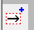
In the design area, click on the point where you want the figure inserted. A dialog containing a list of available figure categories including arrows, electrical symbols and more appears. (NOTE: You can also add your own commonly used shapes as figures so that you can easily insert them into files. Please refer to the Adding Figures to the Figure Library tutorial for more information.) Browse through the categories and select a figure to add, then choose OK.

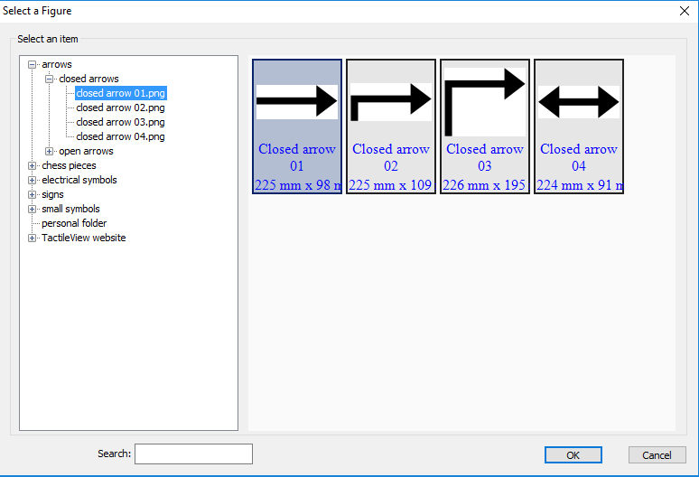
If the object is not the desired size when it appears in the design area, you can edit it. Please refer to the Editing Objects tutorial for more information.
Drawing polygons
To insert a polygon, choose the Draw Polygon icon from the tool bar on the left side of the screen. In the design area, click the location of the first point in your polygon. Click another point to create a line segment between them. Continue creating points connected by straight line segments this way until the shape is the desired size, then click the original point to close the shape.
Polygons may be inserted with as many sides as desired. They may also be edited later to add or remove points, to change the angles between line segments or to change line segment length, to name a few options. For more information on editing shapes, please refer to the Editing Objects tutorial.
Drawing freehand lines or closed shapes
To draw freehand lines or closed shapes, choose the Draw Freehand Line or Closed Shape icon from the tool bar on the left side of the screen. In the design area, click the desired starting location and drag the mouse to create the desired line. To create a closed shape, click the desired starting location and drag the mouse to create the desired shape, returning to the starting location before releasing the mouse button.

For more information about the TactileView program, visit www.dreamvisiongroup.org

