Printing
Before printing a file from TactileView, ensure that the driver for your embosser has been installed onto the computer. Once you have verified that the printer driver is installed on the computer, select Print Setup from the file menu. This will launch the Print Setup dialog.
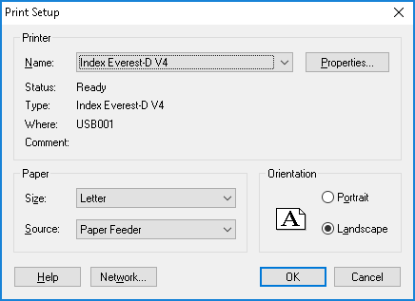
From the Printer Name list, select your embosser. Next, select the paper size you want to emboss on, and choose the print orientation. Select the OK button to save your settings and close the dialog.
If you changed any of the options on the screen, it may affect how your document will print. Depending on the size of your design area and whether it was sized for the paper size you’re using, the file may not make full use of the available space on the paper, or the design may run over slightly onto a second page. Check how your document will print by selecting Print Preview from the File menu. This will open a preview of how your document will print.
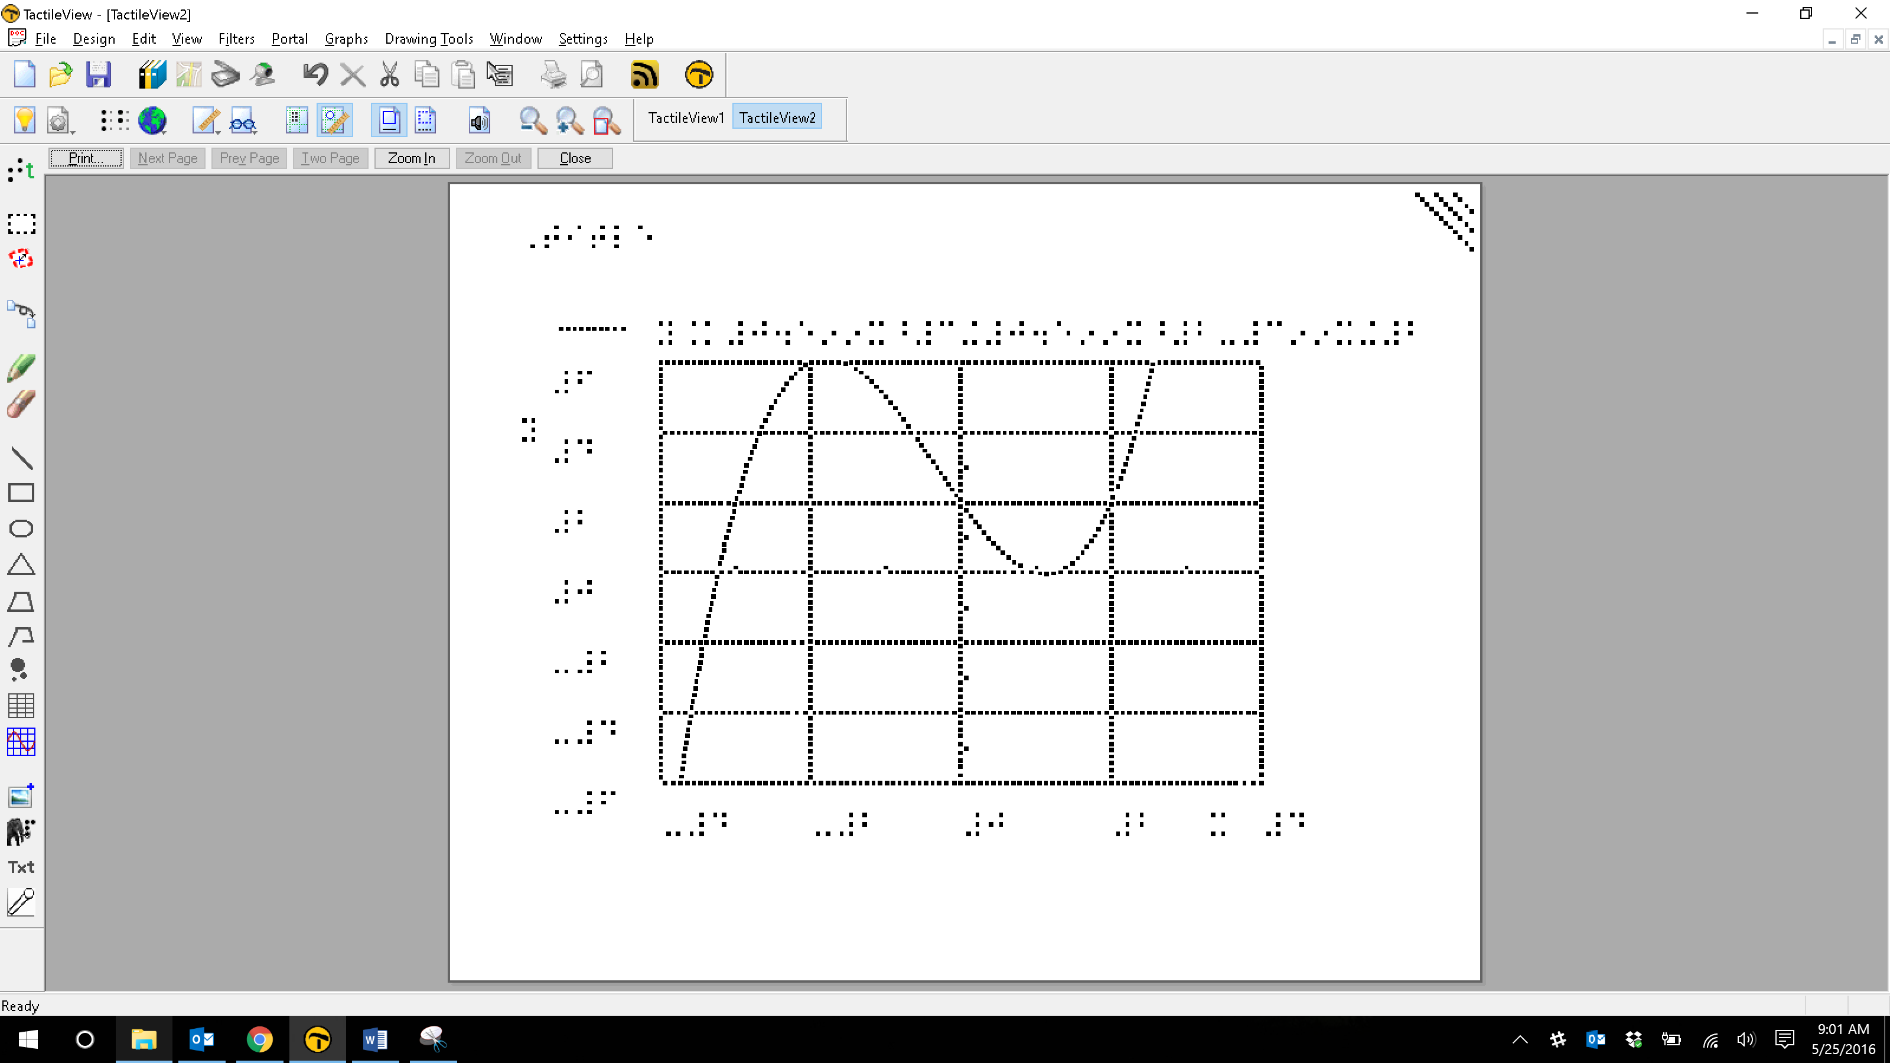
Across the top of the screen are several print preview buttons arranged in a tool bar just above the area that usually contains drawings. If the Next Page button is available, this means that your document is currently configured to print on more than one page. Use the Next Page button to switch the view to the next page that will be printed, or use the Two Pages button to display two pages of your file at a time. When in two page preview mode, the Two Pages button will change to a One Page button to allow you to switch back to one page preview mode. When you are finished previewing your file, choose the Close button to close the preview. If you need to adjust the design area to fit the paper size, please refer to the Changing Design Size and Orientation tutorial.
Once your document appears in the preview the way you want it to print, select Print from the File menu or press CTRL+P to bring up the Print dialog. This is a standard Windows print dialog, which allows you to select which pages to print and how many copies you would like printed. Make the desired selections, then choose the OK button to close the dialog and print the file.

For more information about the TactileView program, visit www.dreamvisiongroup.org

