Graphing and math: Graphing multiple lines
TactileView provides the ability to graph up to four formulas at the same time. If you do not have a file containing a simple (single formula) graph open to work in, open one now or refer to the Creating and Editing a Simple Graph tutorial for instructions on creating one.
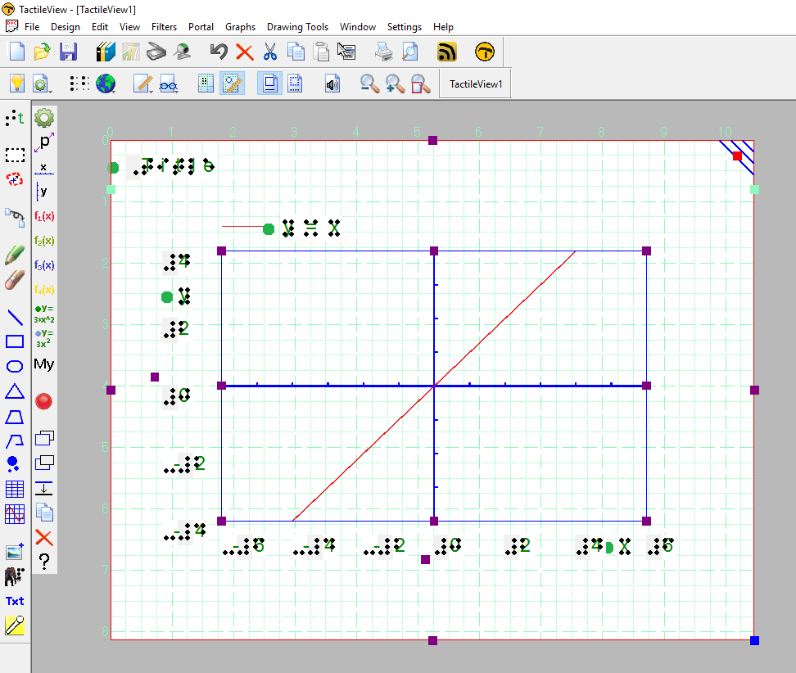
To add another formula line to your graph, select the graph and then choose the Formula 2 icon from the drawing tool bar on the left side of the page, or right-click the graph and choose Formula 2 from the context menu. This launches a dialog you can use to define the properties for the second formula.
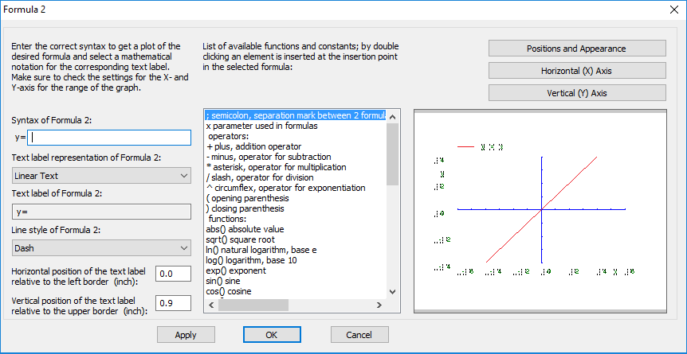
Enter the formula you’d like to use for Formula 2 in the Syntax of Formula 2 field, being careful to use the syntax required for graphing. If you do not know the correct syntax for a function or operator, locate it in the list in the center of the dialog. You can double-click item in this list to insert the operator or function at the cursor location in the Syntax of Formula 2 field, or you can type it into this field as it is shown in the list.
Next on the dialog is the Keep syntax and text the same checkbox. This is checked by default, but if you would like the text label for your formula to be shown in another format, such as in Nemeth braille, this box will need to be unchecked. When unchecked, you can edit the text in the Text Label of Formula 2 text field. If you are entering your own information in the text label, do this now. NOTE: For more information on entering Nemeth braille into your labels, please refer to the Adding Nemeth Labels tutorial.
The next option on this dialog is Graph Style 2, which lets you select the line style of the graph line for this formula. The default for Formula 2 is Dash, but you can change this to Line, Dot or Long/Short Broken if you wish. Select the graph style you would like to use for the second formula. It is recommended to choose a different line style for each formula you enter.
The next two fields allow you to enter the desired position of the text label for the graph of Formula 2 in inches relative to the graph border. Enter the preferred horizontal and vertical position of the graph’s text label.
You can apply your changes to the graph preview on the right side of the dialog at any time by choosing the Apply button. When you are satisfied with your selections on the formula dialog, choose the OK button to save your changes, close the dialog and update your graph.
You can add a third formula by following this same process after selecting the graph and choosing the Formula 3 icon from the tool bar on the left side of the screen or right-clicking the graph and selecting Formula 3 from the context menu. A fourth formula may be added as well using the Formula 4 icon or context menu item.

For more information about the TactileView program, visit www.dreamvisiongroup.org

