Graphing and math: Adding Nemeth labels
Nemeth labels can be added to any document. The best method for adding your Nemeth label will depend on how complex the math used in it is. For simple math, you can enter it and have it translated to Nemeth directly in TactileView. For more advanced math, you will need to use a longer process.
If you know Nemeth code and wish to simply use braille keyboard (six-key) entry to input the desired characters for your label, please refer to the Adding Text Labels tutorial for instructions on adding text labels through six-key entry.
Adding a simple Nemeth math label
When the math you are entering into your label is simple, something like 5x+7=32 or x-9>3, you can create your label entirely in TactileView. If the math is simple enough to be entered on one line without needing parentheses for clarification on order of operations or needing characters that are not available on your keyboard, it can probably be created with this method.
To create your label, click DRAWING TOOLS>Add Text Label: computer keyboard input tab at the top of the screen.
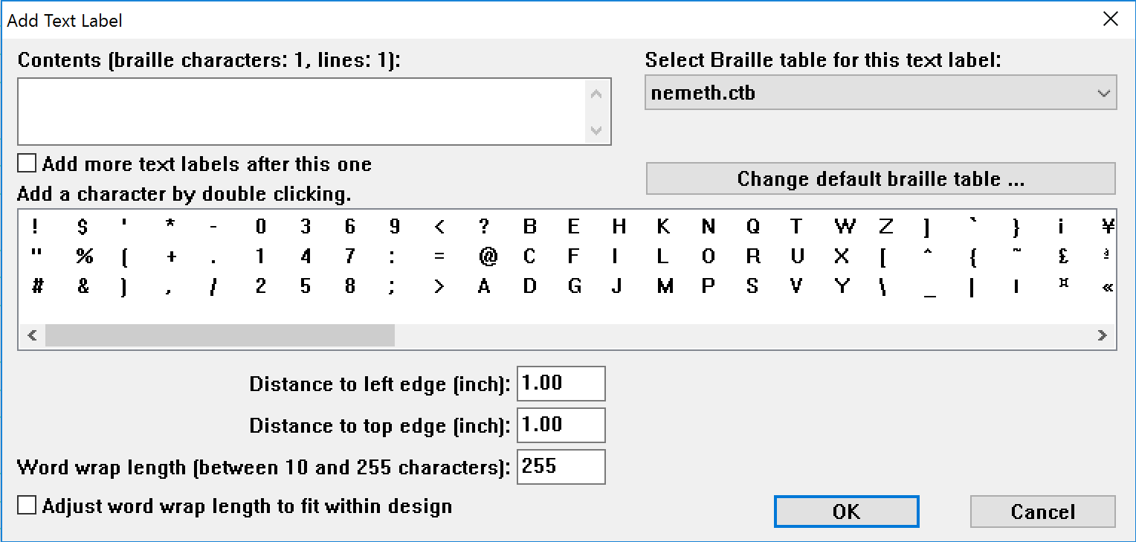
Enter the math into the Contents box. If you need a symbol that is not on the keyboard, such as the square root symbol, locate it in the character box and double-click it to insert it into the Contents box. Select nemeth.ctb as the braille table to use for translation from the Select Braille Table for this Label combo box.
If you’d like, you can adjust the location for your label by editing the values in the distance fields. You can also control the width of the label by specifying the maximum number of characters you’d like it to have before the content wraps to the next line. Choose OK to close the dialog and insert the label.
The Nemeth label will appear in your file with the braille shown in black with the original content you entered in green on top of it. The spacing of the original content may be different than you entered to accommodate for the size of corresponding Nemeth math braille.
Nemeth math labels may be moved and edited the same as other text labels. For more information, please refer to the Editing Text Labels tutorial.
Adding an advanced Nemeth label
When you need to enter math that is too complex to be displayed in linear format without parentheses for clarification or that requires symbols not available from the Add Character box on the add text label dialog, you will need to follow a longer process.
To begin, you will need to use the program Math Type to build your math equation. Once your equation is built, highlight the equation, right click, and select copy. You are now ready to enter the equation into TactileView.
Once in TactileView, select the add text label icon 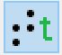, then select the text and position: math input icon 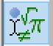 located in the toolbar on the left side of the screen. Select where you want the label by clicking your mouse in the desired location in the file and the add mathematical equation dialogue will appear.
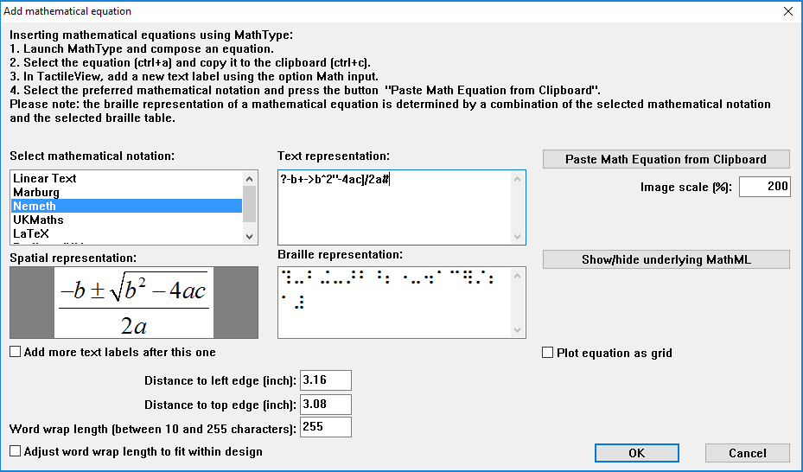
Next, you will need to select the mathematical notation: Nemeth in order to get the equation into the right braille format. Once you have select Nemeth you can add your equation from Math Type by clicking the paste math equation from clipboard icon. Doing this will give you three different representations of the equation: Text, Spatial, and Braille. Once you have pasted the equation from the clipboard, select OK and your equation will be inserted into the TactilView file.
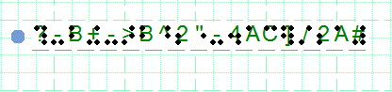
You can also move the label by clicking on the label and dragging it to the desired location.

For more information about the TactileView program, visit www.dreamvisiongroup.org

