Basic editing: Editing objects
NOTE: This tutorial does not cover the use of the menu driven design feature in TactileView. Please refer to the Accessible Drawing tutorial for more information on editing TactileView files through menu driven design.
TactileView offers a number of ways to edit existing objects. Drawing objects are indicated in blue, and all functions listed here will work for these objects. Most will also work for freehand lines that were converted to objects.
To edit an object, click on it to select it. Purple squares will appear at points used to define the object. In most cases, these squares appear along the outline of the object. Objects inserted using the Add Figure feature and freehand lines that have been turned into objects will be surrounded by a red dashed rectangle, with purple and red squares along the dashed rectangle. If you added a freehand line using the Retouching: Adding Lines option it will appear in black on screen, and you will need to convert it to an object before editing (please refer to the Working with a Fused Bitmap tutorial).
Cutting, copying, pasting and deleting objects (all object types)
The fastest way to copy, cut, paste or delete an object is using hotkeys. To cut an object, select it and press CTRL+X on the keyboard. Cutting the object removes it from the file but remembers it so you can paste it somewhere else in the file. The cut object can only be pasted until you cut or copy a different object. To copy an object, select it and press CTRL+C. Copying leaves the original object but keeps a copy of it that you can paste somewhere else in the file. To paste a cut or copied object, press CTRL+V. To delete a selected object, press the Delete key on the keyboard.
Moving objects (all object types)
Once your object is selected, you can move it by clicking the center and dragging it to a new position. You can also easily move the object to the center of the design area by right-clicking it and selecting Center from the context menu.
Resizing objects (all object types)
To change the width of an object, click a purple square on the left or right edge of the object and drag it horizontally until the object is the desired width. To change the height of an object, click a purple square on the top or bottom edge of the object and drag it vertically until the object is the desired height. To scale an object without changing the height to width ratio, click a purple square in one of the corners of the object and drag it diagonally until the object is the desired size.
In the case of a freehand line or closed shape, or for a polygon, clicking and dragging a purple square will move only the point located at that purple square. To resize one of these objects, right-click it and choose Size and Position from the context menu. This will bring up a Size and Position dialog.
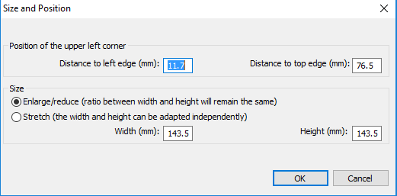
In the Size section of the dialog, choose the Enlarge/Reduce ratio button if you want to scale the object, then specify the desired width or height (the other dimension will adjust accordingly to preserve the original height to width ratio). Choose OK to scale the object. If you want to change the height and/or width independently, choose the Stretch ratio button, then make the desired changes to the height and/or width of the object. Choose OK to close the dialog and update the object.
Rotating objects (all object types)
To rotate an object, right-click it and then choose Rotation from the context menu. On the dialog that appears, enter the desired angle of rotation in degrees and choose OK to rotate the object. You can also use the scroll wheel on a mouse to rotate a selected object.
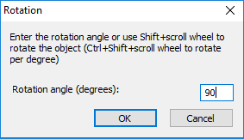
Mirroring objects (figures and retouched objects)
Mirroring an object keeps it in the same position but flips it horizontally or vertically depending on your selection. Mirroring an object horizontally flips it left to right (like turning a page in a book). Mirroring an object vertically turns it upside down (like flipping a page in a wall calendar). To mirror an object, click the Filters tab at the top of the screen and choose to either Mirror Horizontally or Mirror Vertically.
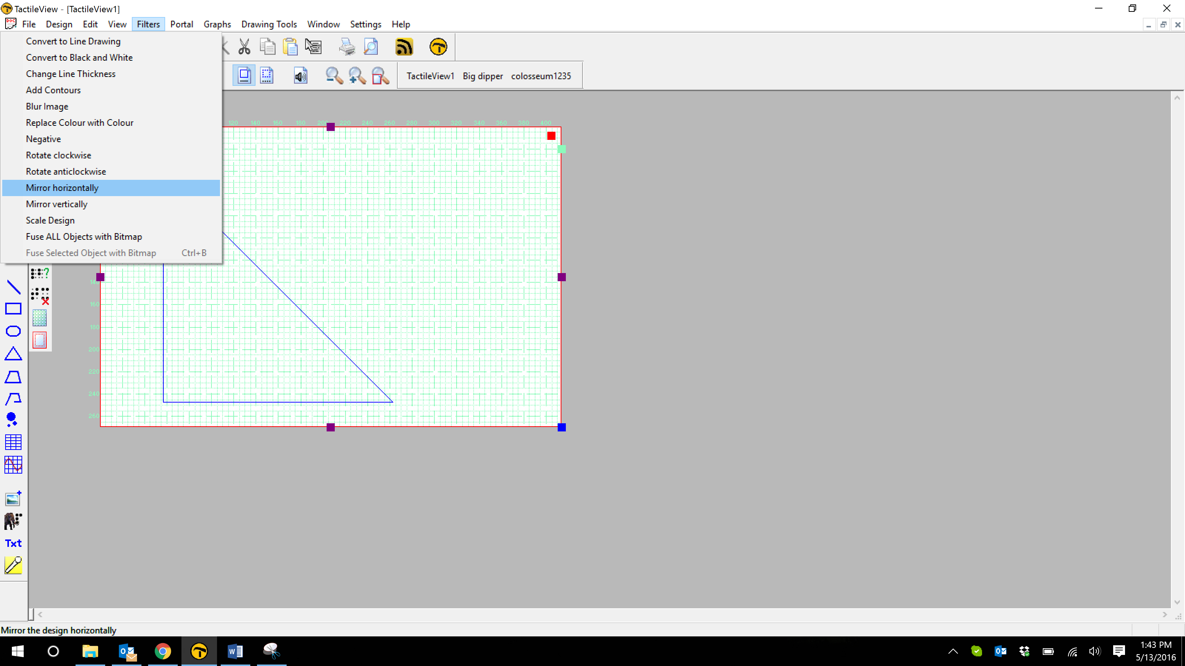
Changing the line style (does not apply to figures or retouched objects)
Select the object and choose the Line Style icon from the tool bar on the left side of the screen, or right-click the object and select Line Style from the context menu. Either of these methods opens a dialog from which you can set the line properties for the object, including the line pattern (solid or dashed) and thickness. The dialog includes a preview of how your line will look as you make changes. Choose OK to apply your changes to the object and close the dialog.
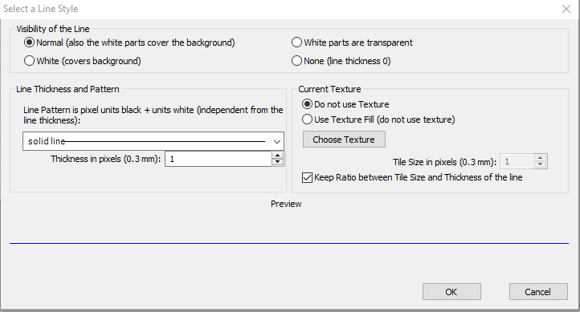
Changing the fill style (does not apply to figures or freehand objects)
Select the object and choose the Fill Style icon from the tool bar on the left side of the screen, or right-click the object and select Fill Style from the context menu. Either of these methods opens a dialog from which you can set the fill properties, including selecting a fill texture, scaling the size of the fill tiles and rotating the texture within the object.
If you would like to add a fill texture to your object, select the Use Texture Fill tick mark. Click the Choose Texture button to bring up a dialog containing a list of textures that can be used. Select a texture and choose OK. A preview of your texture appears at the bottom of the fill style dialog. Use the Tile Size in Pixels edit box to scale the texture larger or smaller. You can also rotate the texture using the Texture Rotation Angle edit box. When you are finished making changes, choose OK to apply the fill to your object.
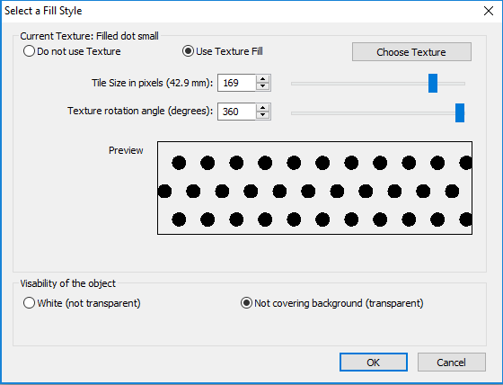

For more information about the TactileView program, visit www.dreamvisiongroup.org

