TactileView Tutorial 1 – Getting Started

First, install your TactileView program from the CD or download. Follow the on-screen prompts to complete the installation. On the last screen, check the 'Start the application' box, then choose 'Finish'.

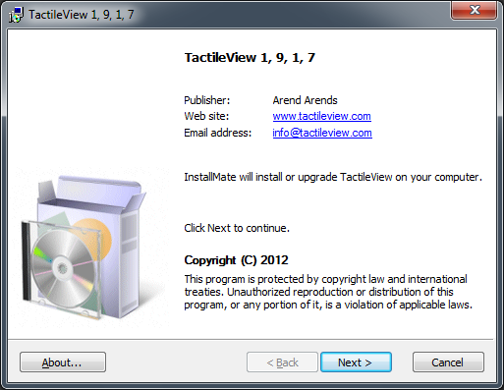

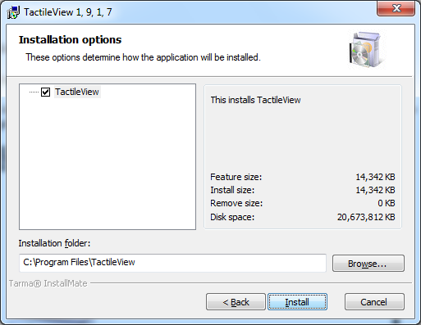

Next, choose your language from the Set User Language dialog. When you have made a selection, choose 'OK'.

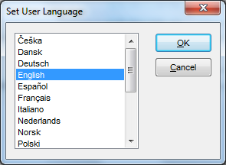

On the next dialog, choose the braille table you wish to use from the list. Please note that for English, you must use either the British braille table or the USA braille table. Once you have made a selection, choose 'Open'.

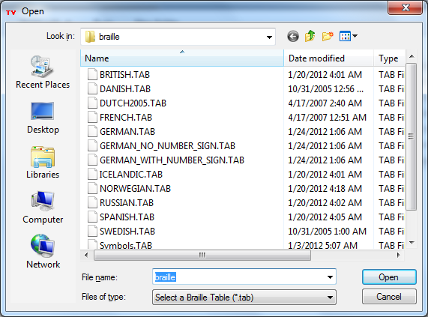

TactileView will now open.

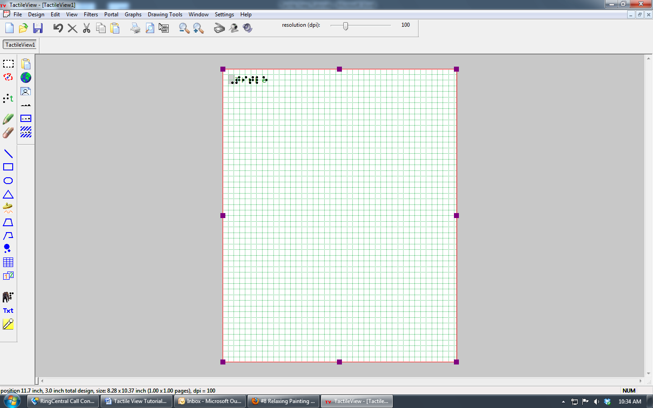

The first time TactileView opens, a TactileView Registration dialog will appear in front of the main TactileView window. It is recommended that you register your product at this time by entering your registration number and choosing 'Register Now'. If you do not wish to register your product at this time, you may choose 'Register Later' on this dialog, but you will not be able to print anything from TactileView until the product is registered. You can access the registration dialog at a later time by choosing 'TactileView Registration' from the HELP menu.
When the registration dialog closes, a TactileView Info dialog will appear. Read the dialog information and then choose 'OK' to close the dialog.

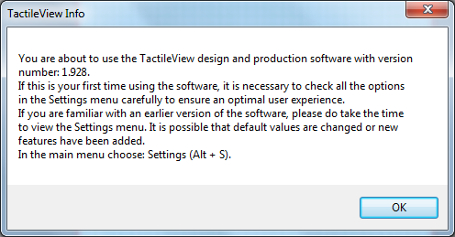

Focus will now return to the main TactileView window.

In order to print properly from TactileView, you will need to install a braille printer. It is suggested that you make sure the braille printer is installed on your computer prior to the use of TactileView. For more information on installing a braille embosser on your computer, consult your braille embosser manual.

From the FILE menu, select 'Install Braille Printer'. *PLEASE MAKE SURE TO HAVE THE LATEST INDEX V4 FIRMWARE LOADED ON YOUR EMBOSSER PRIOR TO EMBOSSING FOR THE BEST RESULTS.

Under Type, choose your braille printer model. For this exercise, we are installing an Index V4 Printer, so we choose 'Index Printer V4.0.5mm'. Under Port, choose the port to which your braille embosser is connected. Under Name, it will display 'Tactileview - Index Printer (V4.0.5 mm)'. Then select 'Install'.

While TactileView is installing the printer, you will see a message indicating this. Please wait. When the installation is finished, a dialog box will pop up information you that the printer and printer driver were installed successfully. Choose 'OK' on this dialog to close it.

Next, select 'Close' on the Install Printer dialog.

Now, to ensure that TactileView does not run in Demo mode, you will need to create a profile. To do this, choose 'Profile' from the SETTINGS menu.

On the Profile dialog that appears, select 'New'.

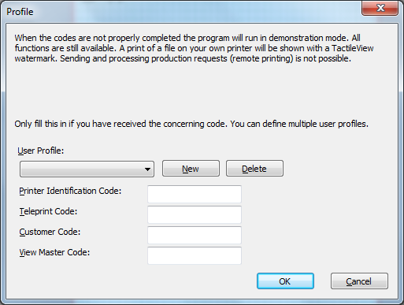

When prompted, provide a profile name, such as Graphics, or a user name. Press 'OK'.

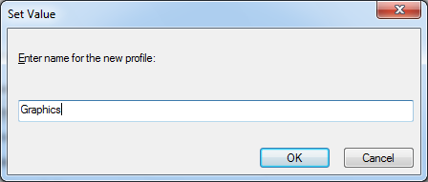

Under the Printer Identification Code, enter any number you wish. It may be as short as one digit. Leave the other options blank, then choose 'OK' to close the Profile dialog. If TactileView is still running in Demo mode, restart it.

For more information about the TactileView program, visit www.dreamvisiongroup.org

