Graphing and math: Creating and editing a simple graph
TactileView offers a very powerful graphing feature, which allows you to enter formulas and have them graphed over a specified range. TactileView gives you precise control over the styles used in your graph for the functions, axes, gridlines, labels and more. You can also move and resize your graph like any other drawing object.
Creating a graph
To begin creating a graph, select Functions and Formulas from the Graphs menu. This will launch a select formula dialog.
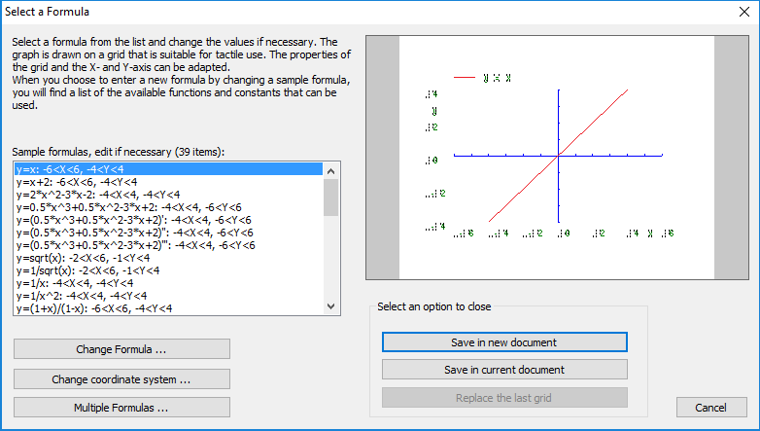
There are dozens of sample formulas available from the select formula dialog. You can choose one of the sample formulas to create a graph from it, or select any sample formula and choose the Change Formula button to edit it or delete it and enter your own formula. The Change Formula button launches a formula dialog.
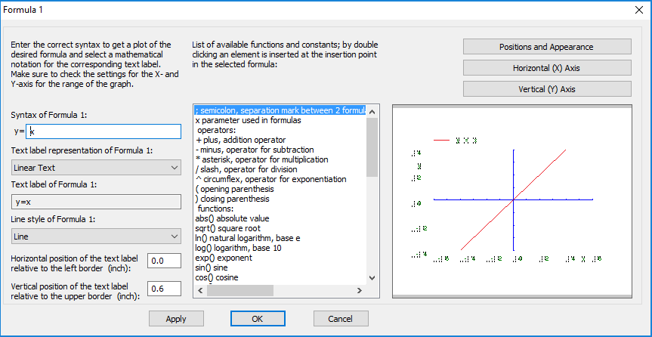
The formula you selected is entered for you in the Syntax of Formula 1 field at the top of the screen. If you wish to edit the formula, you can do so by typing into this field. For proper graphing, it is very important to use the correct syntax. If you do not know the correct syntax for a function or operator, locate it from the list in the center of the dialog. You can double-click item in this list to insert the operator or function at the cursor location in the Syntax of Formula 1 field, or you can type it into this field as it is shown in the list. Make any desired changes to the function here.
Next on the dialog is the Keep syntax and text the same checkbox. This is checked by default, but if you would like the text label for your formula to be shown in another format, such as in Nemeth braille, this box will need to be unchecked. When unchecked, you can edit the text in the Text Label of Formula 1 text field. If you are entering your own information in the text label, do this now. NOTE: For more information on entering Nemeth braille into your labels, please refer to the Adding Nemeth Labels tutorial.
The next option on this dialog is Graph Style 1, which lets you select the line style of the graph line. The default is Line (meaning solid line), but you can change this to Dot, Dash or Long/Short Broken. Select the graph style you would like to use for your graph.
The next two fields allow you to enter the desired position of the graph’s text label in inches relative to the graph border. Enter the preferred horizontal and vertical position of the graph’s text label.
You can apply your changes to the graph preview on the right side of the dialog at any time by choosing the Apply button. When you are satisfied with your selections on the formula dialog, choose the OK button to save your changes, close this dialog and return to the main select formula dialog.
Next, select the Change Coordinate System button to launch the grid properties dialog. This dialog allows you to control the properties of the axes, grid border, tick marks and other coordinate system properties.
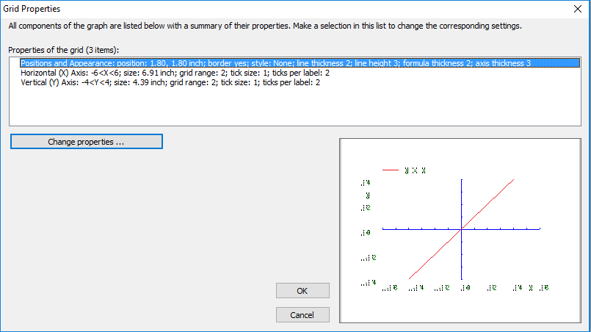
First, select the Positions and Appearance item from the list, then choose Change Properties. This will launch the positions and appearance dialog.
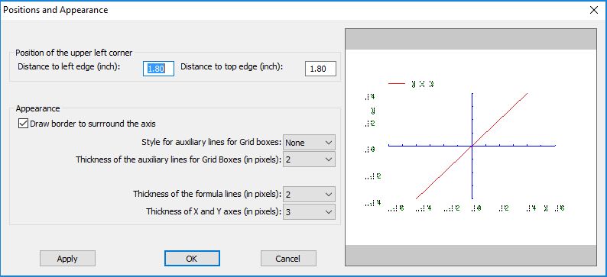
On this dialog, specify the desired position for the upper left corner of the grid on the page. Next, choose whether to draw a rectangular border around the whole graph by checking or unchecking the Draw border to surround the axis option. The default for this option is checked.
Now select what type of grid lines you would like shown on your graph. The default is None. Selecting Line will create solid grid lines, and Dash will create dashed grid lines. Selecting Cross will place a small cross at grid line intersection points, but will not draw the grid lines themselves. Selecting Dot will place a dot at grid line intersection points, but will not draw the grid lines themselves. Once you’ve chosen a grid line style, select the line thickness for grid options using the Thickness of the auxiliary lines for grid boxes (in pixels) edit box. You can preview the different options on your graph by choosing the Apply button at any time.
Next, use the Thickness of the formula lines (in pixels) edit box to adjust the graph line thickness, and use the Thickness in Pixels for X-Axis and Y-Axis edit box to adjust the thickness of the axis lines. When you are finished editing the appearance options, choose OK to close the position and appearance dialog and return to the grid properties dialog.
Now, select the Horizontal (X) Axis, then choose the Change Properties button. This will launch the horizontal (x) axis dialog.
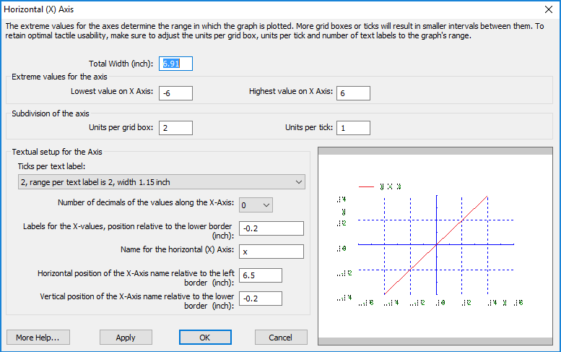
On this dialog, you can adjust the total width of the graph, set the lowest and highest values displayed on the x axis and define the placement of grid lines and tick marks by choosing the number of units per grid box and the number of units per tick mark.
The next section of the dialog allows you to control text labeling along the x axis. Choose how frequently labels appear by selecting a setting from the Number of ticks per text label list. You can remove text labels for this axis entirely, or place them only at the ends, origin or ends and origin of the axis.
You can also set a specific number of ticks per text label; when using this option, selecting a lower number of ticks per text label results in more text labels along the axis, and selecting a higher number of ticks per text label results in fewer text labels along the axis. Next, use the Number of decimals of the values along the X-Axis list to choose how many decimal points to display in the x axis labels, and set the distance between the x axis labels and the axis itself in the Labels for the x-values, position relative to the lower border field.
The last three options on the dialog deal with the label for the x axis. In the Name for the horizontal (x) axis field, type the label you want to use for this axis. The default is x. The other two options let you control the horizontal and vertical position of the x axis name label relative to the left and lower edges of the border, respectively.
Use the Apply button at any time to apply the changes you’ve made on this dialog to the graph preview on the right side of the dialog. When you are finished making changes, choose the OK button to close the horizontal (x) axis dialog and return to the grid properties dialog.
Now, select the Vertical (Y) Axis, then choose the Change Properties button. This will launch the vertical (y) axis dialog. This dialog offers the same options as those available on the horizontal (x) axis dialog, they are just applied to the vertical axis instead. Set these options as desired, choosing the OK button to close the vertical (y) axis dialog and return to the grid properties dialog when you are finished.
Now that you have finished setting the grid properties, choose the OK button to close the grid properties dialog and return to the select formula dialog.
These are the basic settings needed to define your graph. To create the graph, choose the Save in New Document button if you would like to automatically create a new document and place the graph there. If you currently have a blank document open to work in, select the Save in Current Document button to place the graph into it. When either of these buttons is selected, a dialog will pop up asking if you would like to add the new grid to MyGrids, which will allow you to save the graph so that it can be entered into another file later without having to edit all of the properties again.
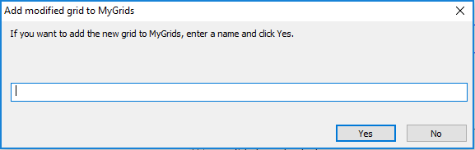
If you would like to save your graph so that you may insert it into another file later, enter a name for it into the text field provided and choose Yes. If you do not want to save this graph so that the same one may be inserted into another file later, choose No. The dialog will close and your graph will be entered into the document.
Editing a graph
Your graph may still be edited after you have placed it into your document. Like drawing objects, you can click on the graph and drag it to move it, or you can click it and drag one of the purple squares along the outside edge of the grid area to resize the graph. Everything that is part of the graph (axis labels, grid lines, axes, graph lines, etc) will be scaled and moved together.
You can also edit any of the properties you set when you created the graph. To edit the grid properties, select the graph and choose the Grid Properties icon 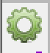 from the tool bar on the left side of the screen, or right-click the graph and choose Properties grid 1 from the context menu. This brings up the grid properties dialog, where you can edit any of the grid properties you previously set.
To edit the position and appearance properties, select the graph and choose the Size and Position icon from the tool bar on the left side of the screen, or right-click the graph and choose Size and Position from the context menu. This brings up the position and appearance dialog, where you can change the graph position by entering coordinates, or edit any of the appearance settings you previously set.
To edit the horizontal axis properties, select the graph and choose the Horizontal (X) Axis icon from the tool bar on the left side of the screen, or right-click the graph and choose Horizontal (X) Axis from the context menu. This brings up the horizontal (x) axis dialog, which you can use to change any of the properties for the x axis. Likewise, selecting the graph and choosing the Vertical (Y) Axis icon from the tool bar on the left side of the screen or right-clicking the graph and choosing Vertical (Y) Axis from the context menu launches the vertical (y) axis dialog, which can be used to change the properties for the y axis.
You can even edit the formula shown in the graph after the graph has been inserted into the document. To edit the formula, select the graph and choose the Formula 1 icon from the tool bar on the left side of the screen, or right-click the graph and choose Formula 1 from the context menu. This launches the formula dialog where you can change the formula used, the text label for it and the text label’s position, as well as the type of line used for the formula graph line.
There are additional options available for graphing more than one formula on the same graph. For more information, please refer to the Graphing Multiple Lines tutorial.
For more information about the TactileView program, visit www.dreamvisiongroup.org

