Advanced editing: Working with fused bitmaps
Sometimes it is necessary to work with a file in which the drawing is all one piece, a fused bitmap. When the drawing objects are fused to the bitmap in a file, they may not be moved or altered in any way, but it is possible to convert parts of a bitmap back to editable objects.
Converting a selected area to an object
Objects that are part of a fused bitmap appear in black, and it is not possible to select them. To convert a selected area to an object, choose the Select Area icon from the tool bar on the left side of the screen, or choose Select Area from the Drawing Tools menu. Then click and drag the mouse to select a rectangular area around the part of the bitmap you wish to turn into an object. Once the area is selected, it will be surrounded by a red dashed rectangle, with purple, blue and red squares along the dashed rectangle. Right-click anywhere inside the selected area and choose Convert to Figure. The blue squares will disappear, and the object may now be edited in the same way as any other figure object. For instructions on editing figures, please see the Editing Objects tutorial.
Detecting shapes
If you have a closed shape in your bitmap that’s not well suited to a rectangular area, you can use the detect shape feature.
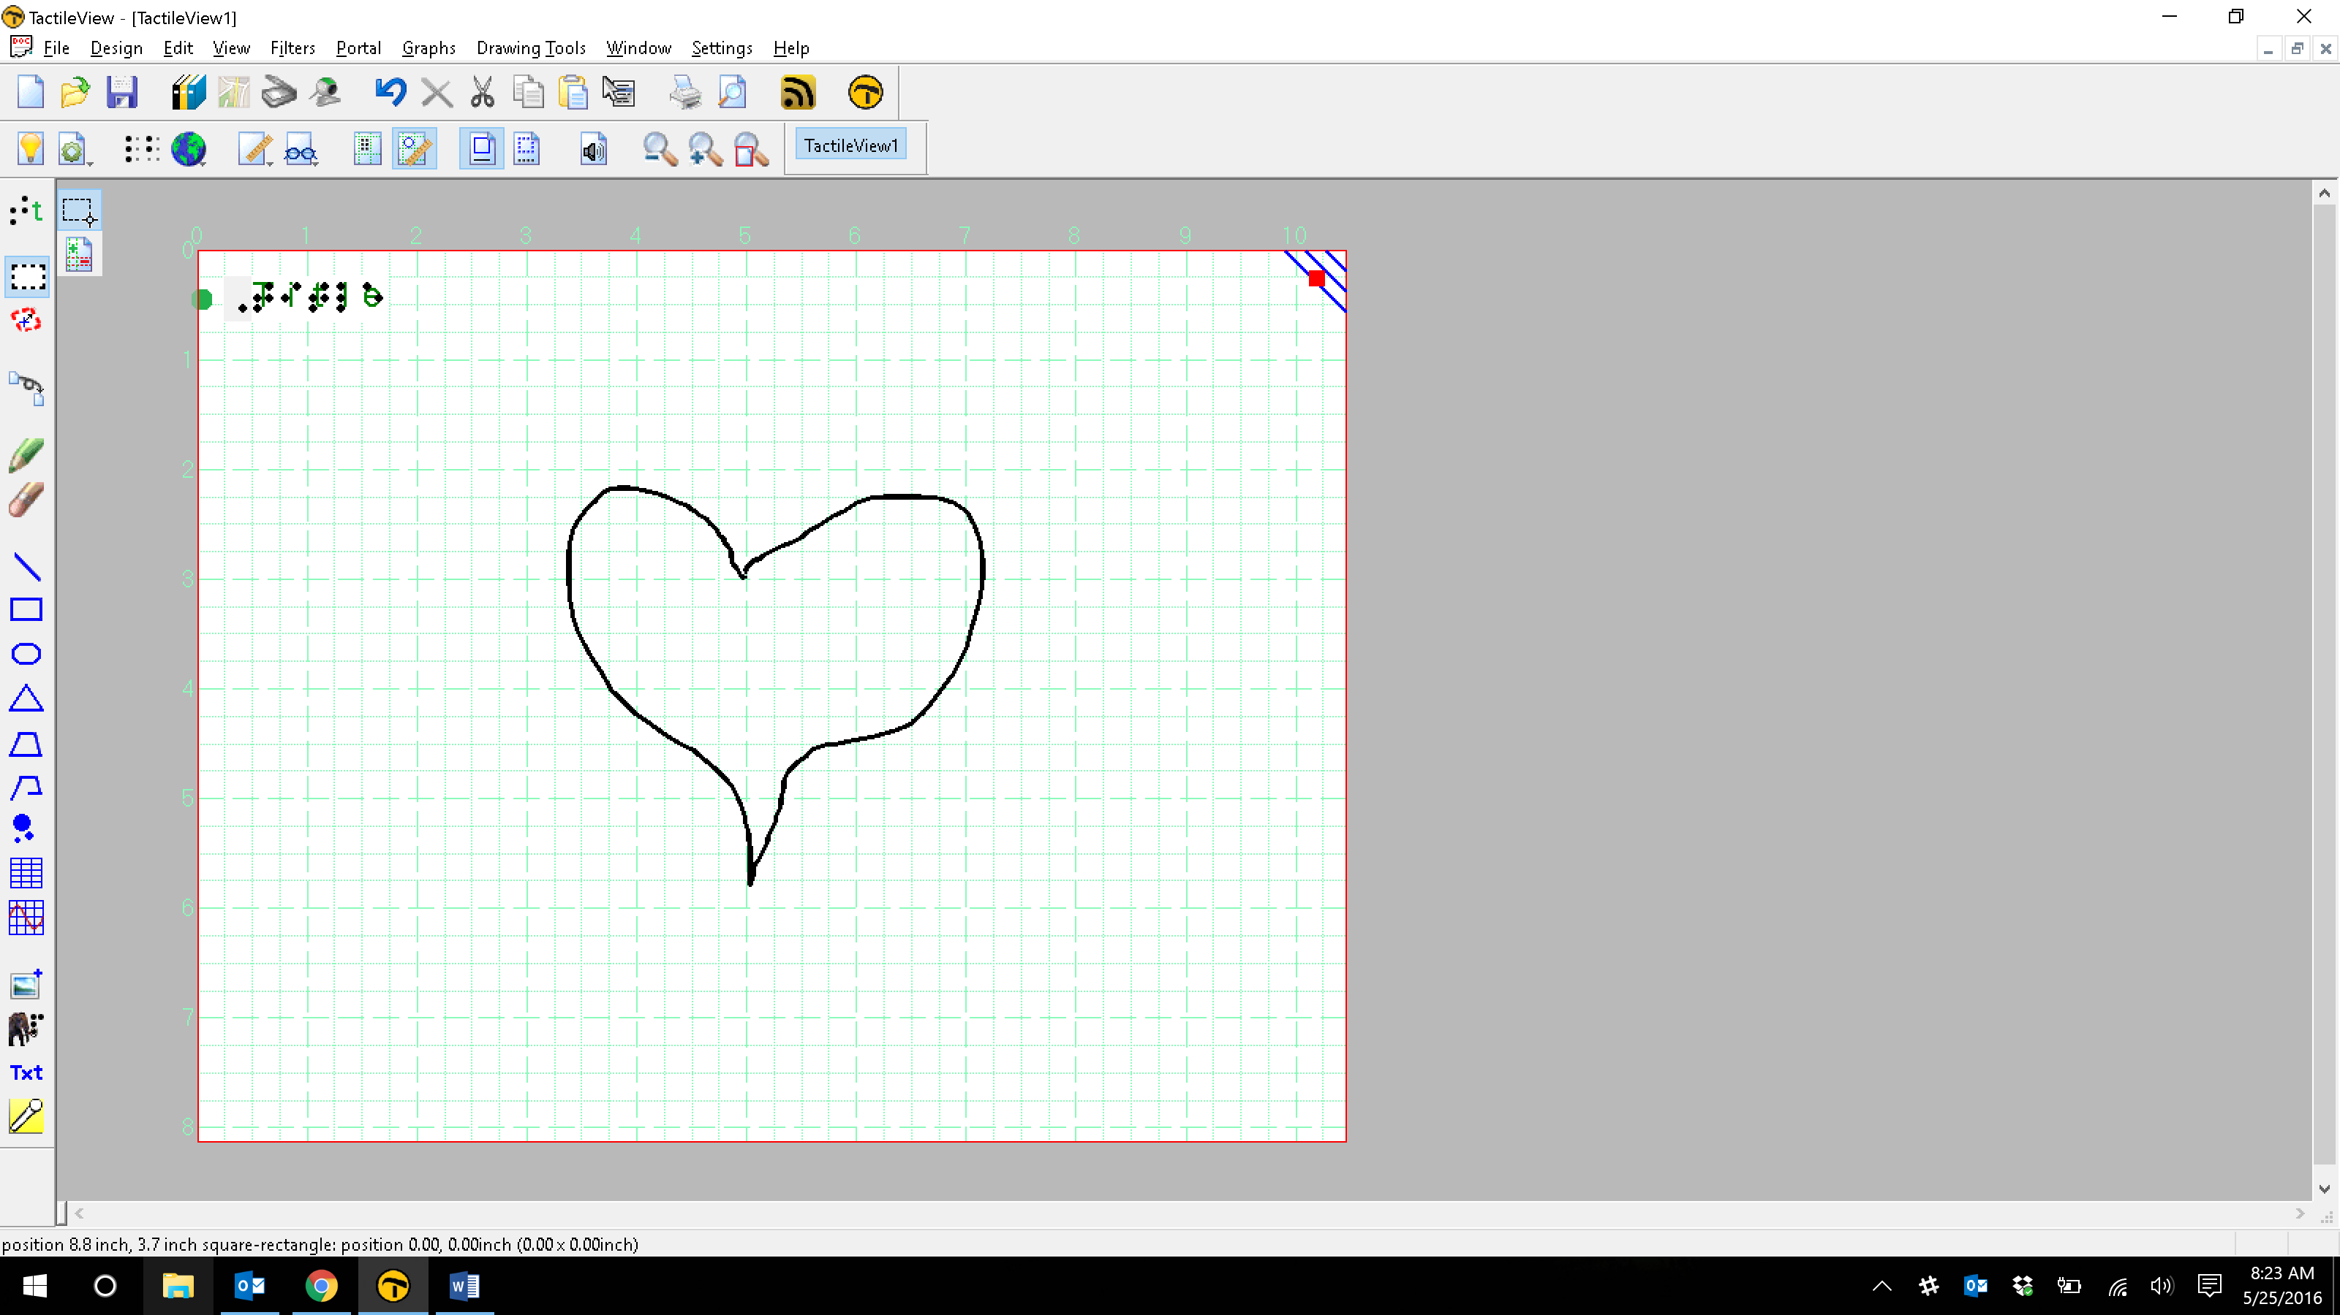
Select the Detect Shape icon from the tool bar on the left side of the screen, or choose Detect Shape from the Drawing Tools menu. Click in the center of the closed shape you wish to detect. An object will be created that is bounded by the closed shape. The object will have purple squares at defining points around the outside contour.
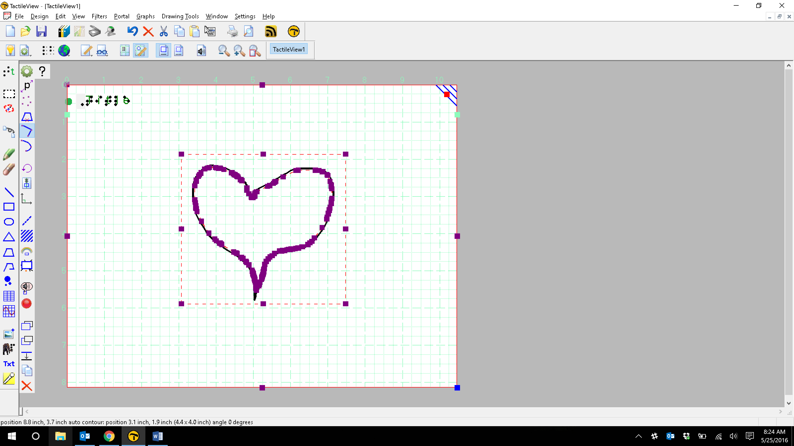
To add a line around the outside of this object, choose the Line Style icon from the tool bar at the left side of the screen, or right-click the object and choose Line Style from the context menu. This will launch the line style dialog.
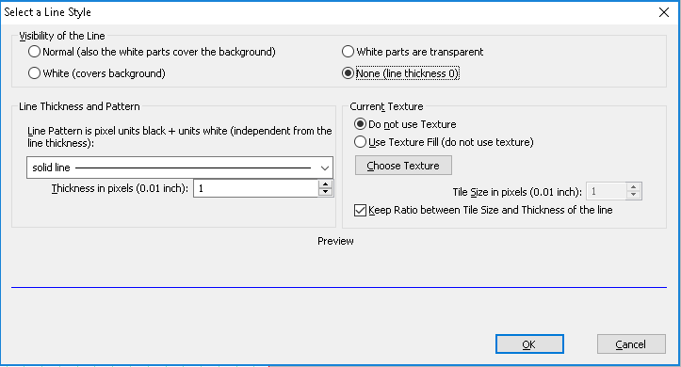
By default, the visibility of the line is set to the None tick mark. Select the Normal tick mark to add a line surrounding the object. You can also set other line properties as desired on this screen. For more information on changing line properties, please refer to the Editing Objects tutorial. When you are finished making changes, choose the OK button to close the dialog and apply your changes. Now you have an editable object that matches your original closed shape.
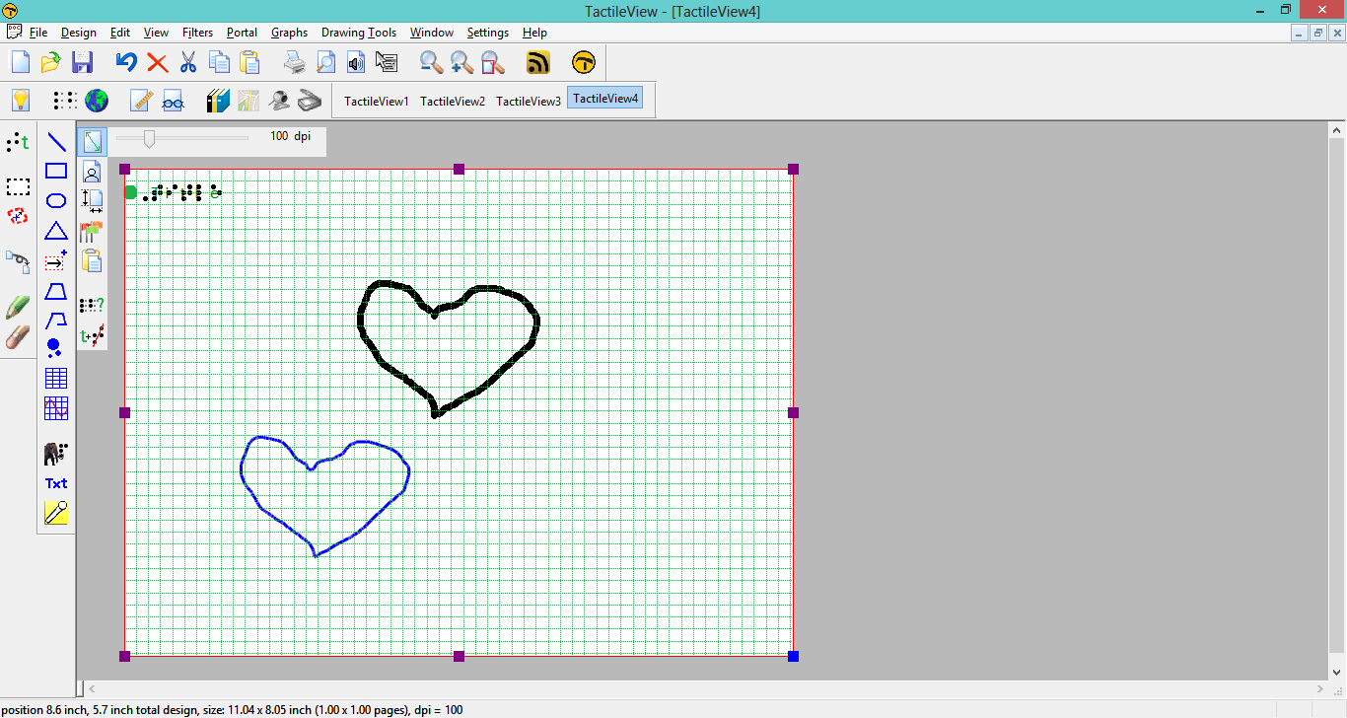
The original closed shape can be erased if desired using the retouching options.
Retouching
To draw freehand lines that are automatically part of the bitmap and not editable, select the Retouching; Adding lines icon from the tool bar on the left side of the screen, or select Retouching; Adding lines from the Drawing Tools menu. Select the line thickness you would like to use prior to starting to draw by choosing a line thickness in pixels from the tool bar
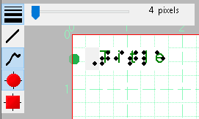, or by right-clicking in the design area and choosing a line thickness in pixels from the context menu.
You can now use the mouse to draw in the design area. Anything you draw with this tool will automatically be part of the bitmap and will not be editable unless you select an area containing your drawing and convert it to a figure or use the detect shape feature to create an editable object from a freehand closed shape. The retouching mode will continue until you select another mode or drawing tool, or until you press the escape key on the keyboard.
To erase lines in the bitmap, select the Retouching; Erase icon from the tool bar on the left side of the screen, or select Retouching; Erase from the Drawing Tools menu. Select the eraser width you would like to use prior to starting to erase by choosing the width in pixels from the tool bar
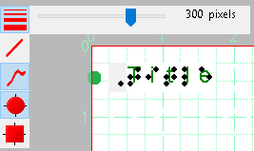, or by right-clicking in the design area and choosing an eraser width from the context menu.
Begin erasing by dragging the mouse over the lines you would like to erase. The retouching mode will continue until you select another mode or drawing tool, or until you press the escape key on the keyboard. You can erase any lines fused to the bitmap, but editable objects may not be erased. For more information on editing objects, including deleting them, please refer to the Editing Objects tutorial.
Fusing objects to the bitmap
Editable objects can be fused to a bitmap at any time. To fuse an object to the bitmap, select it and then choose the Fuse Object with Bitmap icon from the tool bar at the left side of the screen, or right-click it and choose Fuse object with bitmap from the context menu. The editing markers (purple and/or red squares around the object) will disappear and the object will turn black and no longer be editable. If you fuse an editable object to the bitmap accidentally, you can choose Undo from the Edit menu, press CTRL+Z or click the Undo icon from the tool bar across the top of the screen to undo this action and retrieve the editable object.
For more information about the TactileView program, visit www.dreamvisiongroup.org

