Basic editing: Changing design orientation and size
In TactileView, the “design” size refers to the size of the drawing area, represented on the screen by a white rectangle. The design size might not always match the paper size and orientation you’re using (indicated by a red rectangle or rectangles on screen), especially if you’re working on a design downloaded from the catalog or a file created by importing a jpeg or other image file.
By default, when you create a new file, the design area is sized and oriented to match the paper size and orientation currently set in your print setup. For example, if letter (8 ½ x 11 inch) paper in portrait orientation is set in your print setup, the design area in new files you create in TactileView will be created with this size and orientation.
If the design size and orientation are not set to what you want to use, it’s best to change them prior to beginning to work on the file. To change the orientation of the design area, open the Design menu. If your design is currently set to portrait orientation, the first item in the menu will be Change Orientation to Landscape. If your design is currently set to landscape orientation, the first item in the menu will be Change Orientation to Portrait. Select this first menu item to change the orientation of the design. NOTE: This option only changes the design orientation; if you wish to change the paper orientation for printing, you will need to change that separately (please refer to the Printing tutorial).
The dimensions of the design area can be changed at any time by clicking on a blank space in the design area. Squares will appear around the outside of the design area. The purple squares adjust only the design area. Click and drag a purple square along the top or bottom edge vertically to increase or decrease the height of the design area, or click and drag a purple square on the left or right edge horizontally to increase or decrease the width.
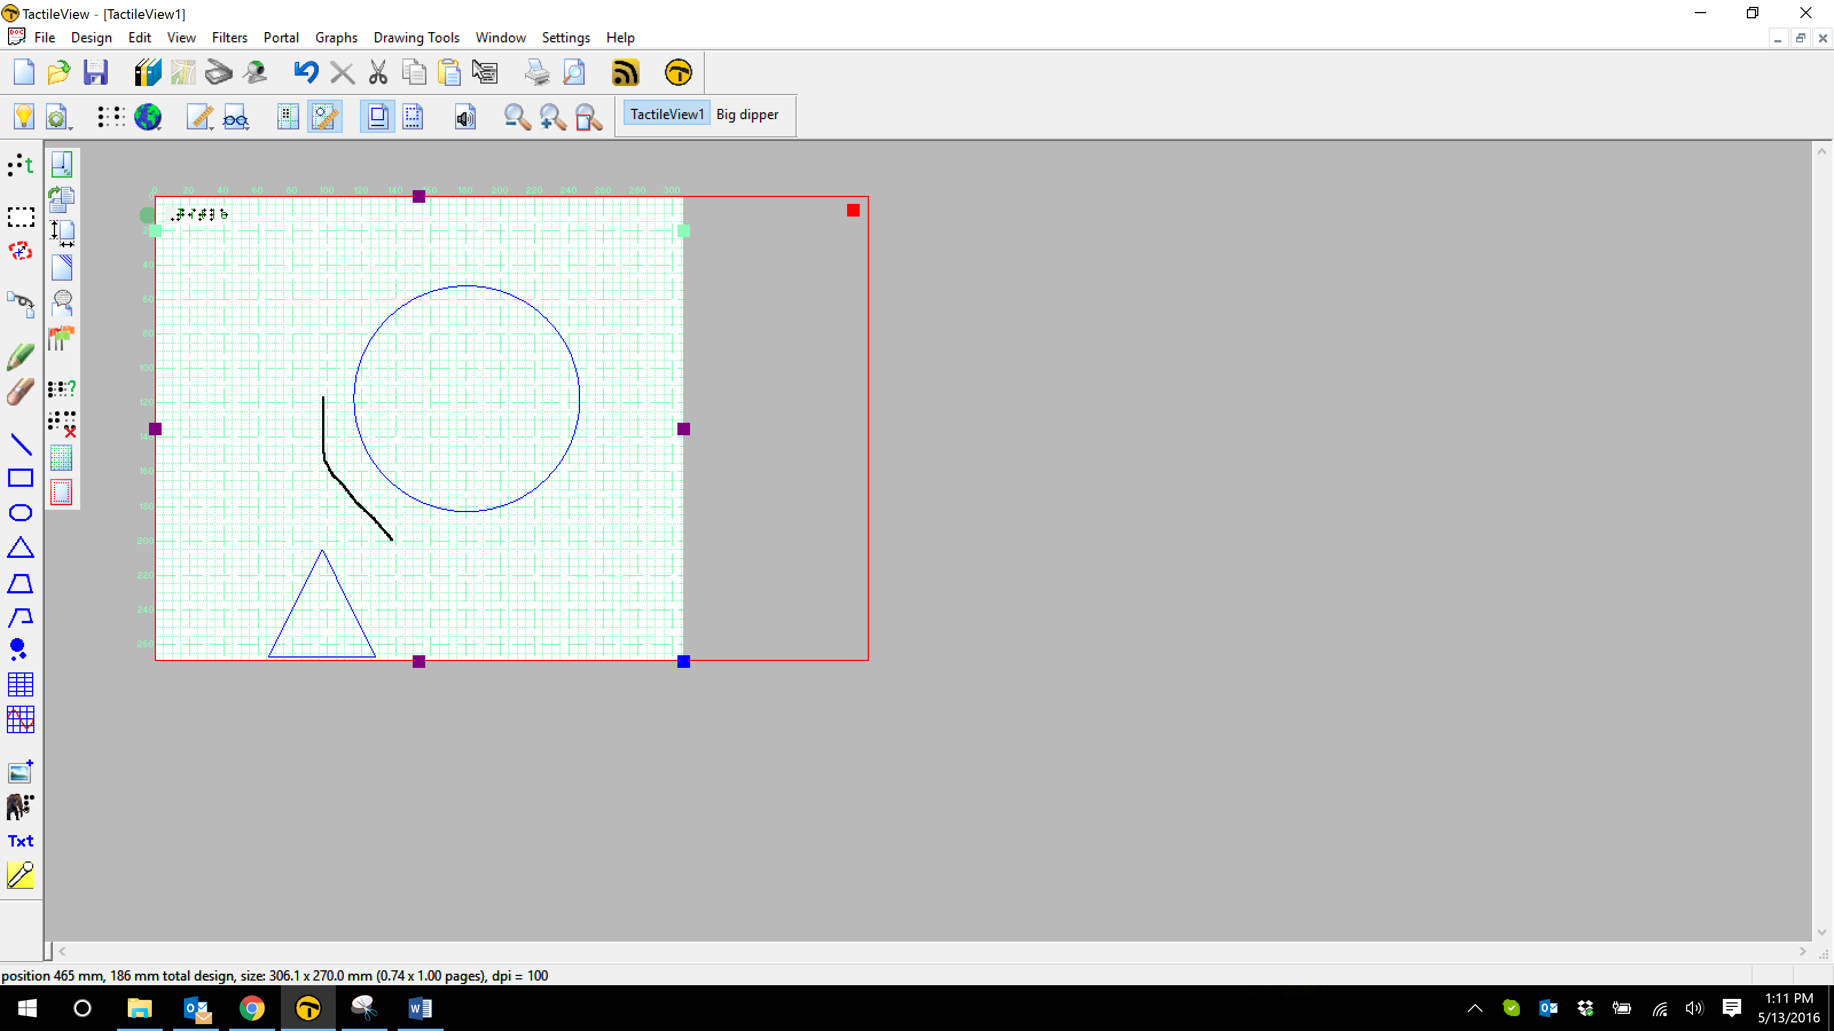

The square in the lower right corner of the design area is blue. The blue square lets you click and drag to scale the design area and the picture together. This is useful when you’ve downloaded a file from the catalog and it’s not sized to fit the paper you’re using.
Example:
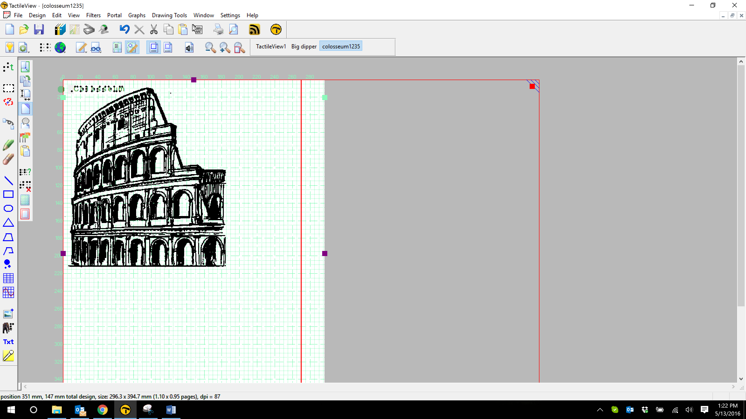
The two red rectangles indicate that this design will print on two pages. Click and drag the blue square at the lower right corner of the design area to scale the picture down until it fits on one page. You can also let TactileView scale the image down to one page for you by choosing Scale Picture to Paper Size Now from the Edit menu.
To allow TactileView to scale pictures automatically to fit the paper, you can choose Scale Pictures Automatically to Paper Size from the Edit menu. This option will automatically scale the design area and picture to fit onto one page of the paper size currently selected in your print setup when you open a downloaded file or create a new file from a jpeg or other image file. NOTE: When this option is selected, TactileView will also choose the design orientation that best fits the design area and picture, but it will not change the paper orientation in your print setup. Always ensure that your paper orientation matches the design orientation before embossing any file.
Once the design orientation and size are set up as desired, you’re ready to begin work on your file!

For more information about the TactileView program, visit www.dreamvisiongroup.org

