Advanced editing: Drawing and editing tables
TactileView includes a number of tools for drawing and working with tables. As drawing objects, most editing commands for tables are the same as for other drawing objects, including the methods with which to move, center or delete a table, change it’s line or fill style, add audio labels or fuse it to the bitmap. For more information on these topics, please refer to the Editing Objects, Adding Audio Labels and Working with Fused Bitmaps tutorials. The features and commands described in this tutorial are specific to tables.
Drawing a table
To add a table to your file, choose the Draw Table icon from the tool bar on the left side of the screen, then click and drag the mouse to insert a table into your document. Your table will be created with the default number of rows and columns, but you can add and/or remove rows and columns as desired after the table has been inserted.
Another way to add a table to your file is to select Draw Table from the Drawing Tools menu. Once you have placed your table in the file, right click on the table you wish to adjust and select the Size and Position of the Table option. This launches a dialog allowing you finer control over how the table is initially created.
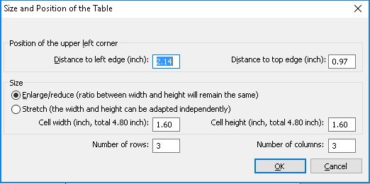
To insert a table using this method, enter the desired location of the upper left corner of the table, then specify the size parameters, the number of rows desired and the number of columns desired. When setting the size, choose the Enlarge/reduce tick mark if you would like the cells in your table to be square, or choose the Stretch tick mark to allow adjustment of the height and width independently. Enter the desired cell width (and the height, if using the Stretch option), the desired number of rows and the desired number of columns, then choose OK to close the dialog and insert the table into your drawing.
Adjusting the table size
Once you have inserted the table into your drawing, you can adjust the overall table size. To do this, select the table so that purple squares appear along the outside edges of the table. To scale the table and preserve the height to width ratio, click a purple square in one of the corners of the table and drag it until the table is the desired size. The cells in the table to be scaled up or down automatically with the table and maintain their height to width ratios as well.
To adjust the overall table width, click the center purple square on the right or left edge of the table and drag it until the table is the desired width. The cells in the table will be scaled automatically to maintain equal widths. Similarly, you can adjust the overall table height by clicking the center purple square on the top or bottom edge of the table and dragging it until the table is the desired height. The cells in the table will be scaled automatically to maintain equal heights.
Adding and removing rows and columns
If you created your table using the tool bar icons and the default number of columns and/or rows is not what you need, you can add or remove rows or columns. To add a row, select the table and choose the Add Row icon from the tool bar at the left side of the screen, or right-click the table and choose Add Row from the context menu. A dialog will appear, allowing you to choose where in the table to add the row and how to change the size of the table or rows to accommodate the new row.
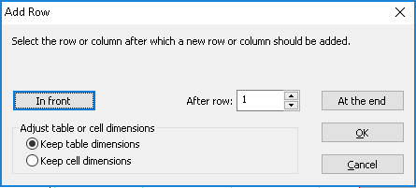
First, choose the Keep Table Dimensions tick mark if you want to maintain the current outer dimensions of the table (scale the row height of all rows down to add the new row without changing the overall table size), or choose the Keep Cell Dimensions tick mark if you want to add a row with the same dimensions as the cells currently in the table (increase the overall height of the table to add the new row with the same row height as current rows). Next, select where to add the new row. To add the new row at the top of the table, choose the In Front button to close the dialog and add the row. To add it at the bottom of the table, choose the At the End button to close the dialog and add the row. To add it somewhere else in the table, use the After Row edit box to enter the row number after which the new row should be added, then choose OK to close the dialog and add the row.
To remove a row, select the table and choose the Delete Row icon from the tool bar at the left side of the screen, or right-click the table and choose Delete Row from the context menu. A dialog will appear, allowing you to choose which row in the table to remove and how to change the size of the table or remaining rows once it’s removed.
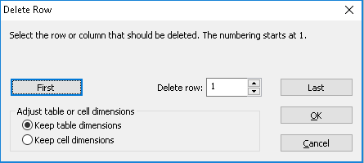
First, choose the Keep Table Dimensions tick mark if you want to maintain the current outer dimensions of the table (increase the row height of all remaining rows to remove the row without changing the overall table size), or choose the Keep Cell Dimensions tick mark if you want to remove the row without changing the height of the remaining rows (decrease the overall height of the table when the row is removed). Next, choose which row to remove. To delete the row at the top of the table, choose the First button to close the dialog and remove the row. To delete the row at the bottom of the table, choose the Last button to close the dialog and delete the row. To delete any row in between, use the Delete Row edit box to enter the row number to remove, then choose OK to close the dialog and delete the row.
To add a column, select the table and choose the Add Column icon from the tool bar at the left side of the screen, or right-click the table and choose Add Column from the context menu. A dialog will appear, allowing you to choose where in the table to add the column and how to change the size of the table or existing columns to accommodate the new column.
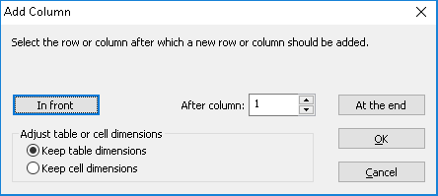
First, choose the Keep Table Dimensions tick mark if you want to maintain the current outer dimensions of the table (decrease the width of all of the columns to add the new column without changing the overall table size), or choose the Keep Cell Dimensions tick mark if you want to add a column containing cells with the same dimensions as the cells currently in the table (increase the overall width of the table to add the new column with the same width as the existing columns). Next, select where in the table to add the new column. To add the new column to the left edge of the table, choose the In Front button to close the dialog and add the column. To add it to the right edge of the table, choose the At the End button to close the dialog and add the column. To add it somewhere else in the table, use the After Column edit box to enter the column number after which the new column should be inserted, then choose OK to close the dialog and add the column.
To remove a column, select the table and choose the Delete Column icon from the tool bar at the left side of the screen, or right-click the table and choose Delete Column from the context menu. A dialog will appear, allowing you to choose which column in the table to remove and how to change the size of the table or remaining columns once it’s removed.
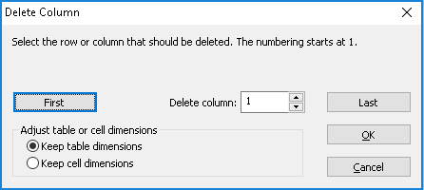
First, choose the Keep Table Dimensions tick mark if you want to maintain the current outer dimensions of the table (increase the width of all remaining columns to remove a column without changing the overall table size), or choose the Keep Cell Dimensions tick mark if you want to remove the column without changing the width of the remaining columns (decrease the overall width of the table when the column is removed). Next, choose which column to remove. To delete the column at the left edge of the table, choose the First button to close the dialog and remove the column. To delete the column at the right edge of the table, choose the Last button to close the dialog and delete the column. To delete any column in between, use the Delete Column edit box to enter the column number to remove, then choose OK to close the dialog and delete the column.
Entering table contents
At any point after creating your table, you can enter contents into the cells. To do this, select the table and choose the Table Contents icon from the tool bar at the left side of the screen, or right-click the table and choose Table Contents from the context menu. This launches a dialog from which you can control the table content.
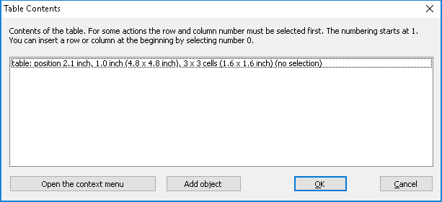
From this dialog, select the Add Object button to open the add object context menu. This menu contains a list of the type of objects you can add as table content.
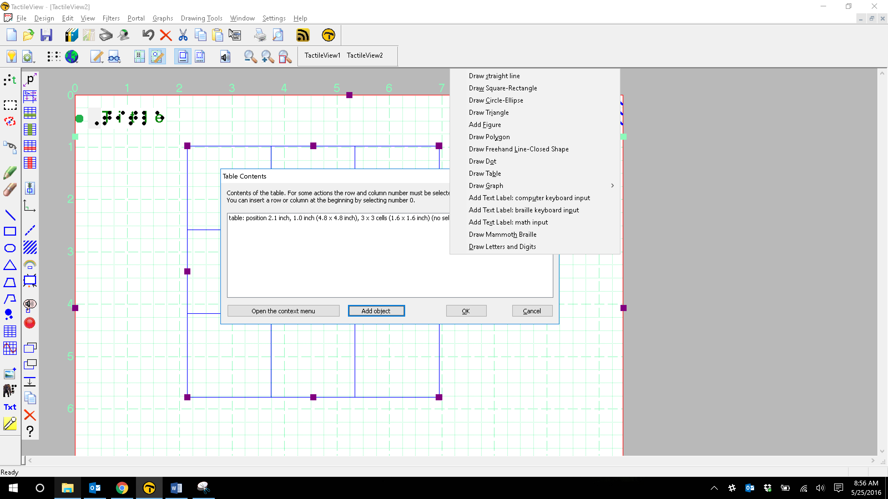
When you select an object type from this menu, a dialog will come up allowing you to give further information about the object you want to create. What is on the dialog will vary depending on which type of object you select. A size and position dialog will appear for straight lines, squares/rectangles, circles/ellipses, triangles, polygons, freehand lines/closed shapes, dots and tables. When Add Figure is selected, a select figure dialog will appear first, allowing you to select the type of figure to insert and the size and position dialog will appear after that. When Draw Mammoth Braille or Draw Letters and Digits is selected, a contents and position dialog is launched instead of the size and position one. Choosing Add Text Label brings up an add text label dialog.
The dialogs are very similar to the ones that appear when you access the drawing tools from the Drawing Tools menu, except that they also have edit boxes that allow you to select which cell to place the object in by specifying the desired row and column for the object.
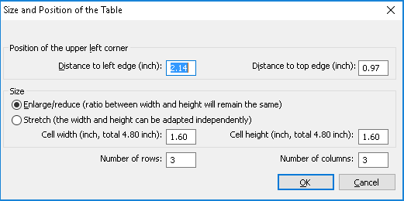
This is the size and position dialog for inserting a square, but since it is being inserted into a table it has Row in Table and Column in Table edit boxes at the bottom. Make the desired selections to create your object and place it in the appropriate cell, then choose OK to close the dialog and insert the object into the table. It will also appear as a listing in the table contents menu.
Objects inserted into a table may be edited just like objects that are not part of table contents (for more information, please refer to the Edit Objects or Adding and Editing Text Labels tutorials). Inserting an object into the table contents will anchor it to the table, so that if you later move, stretch or scale the table, the object stays linked to the correct cell in the table.
If you do not need to move or otherwise edit the table after placing it into the document, it is possible to simply draw objects or create labels on top of the table using the standard drawing tool bar icons and the mouse. This is only recommended if you are certain you will not need to resize or move your table, because objects can’t be grouped or multi-selected so that more than one can be resized or moved at a time.

For more information about the TactileView program, visit www.dreamvisiongroup.org

