TactileView Tutorial 2 – Introduction to the Menus and Toolbar

In this tutorial we will explore the TactileView menus and toolbar to provide more detail on the functionality of the options. Below is the description of the standard toolbar options. You may have more icons in your toolbar, depending on what is selected in your document.

Let’s begin by exploring the menu bar:

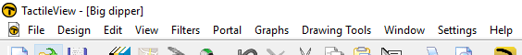

As with most software programs, menus may be accessed using keyboard shortcut commands (hot keys). To access a menu without a mouse, press ALT plus the letter for the desired menu. The following are the available menus, in order from left to right, with the letter for that menu's hot key in parentheses following the menu name: FILE (F), DESIGN (D), EDIT (E), VIEW (V), FILTERS (I), PORTAL (P), GRAPHS (G), DRAWING TOOLS (T), WINDOW (W), SETTINGS (S) and HELP (H). For complete information on the options available in each menu, please reference the program user manual.

Certain frequently used functions have been assigned their own icons in the vertical toolbar on the left side of the screen. These functions may also be accessed through the menus.
The Select Area Tool (DRAWING TOOLS>Select Area) is the first option in the drawing toolbar. This allows you to select an area of an object or an entire object. When selected, a submenu will appear to allow you to edit your selection, including cutting, pasting, rotating and more.
The Detect Shape Tool (DRAWING TOOLS>Detect Shape) allows you to locate an object by clicking on the drawing where the shape is believed to be. The nearest object will be selected.

The Add Text Label Tool (DRAWING TOOLS>Add Text Label) allows you to insert a text and braille label into your document to label your diagram. When you have selected a location for your label a dialog window will appear, allowing you to customize your label text, braille table and other parameters.
The Retouching/Adding Lines Tool (DRAWING TOOLS>Retouching; Adding Lines) allows you to free hand draw lines in your document. When selected, additional toolbar
icons will appear, allowing you to change the thickness of your lines. Please note that the size of the mouse pointer will change based on the line thickness selection.

The Retouching/Erase Tool (DRAWING TOOLS>Retouching; Erase) allows you to erase lines in your diagram. When selected, additional toolbar icons will appear, allowing you to change the thickness of your eraser. Please note that the size of the mouse pointer will change based on the eraser thickness selection.
The Shape Tools allow you to insert a basic line (DRAWING TOOLS>Draw straight line), rectangle/square (DRAWING TOOLS>Draw Square-Rectangle), circle/oval (DRAWING TOOLS>Draw Circle-Ellipse) or triangle (DRAWING TOOLS>Draw Triangle). When a shape tool is selected, additional toolbar icons will appear that allow you to customize the style of your shape.

The Add Figure Tool (DRAWING TOOLS>Add Figure) allows you to add a premade shape to your document. After selecting a location for your figure, a dialog window will appear to allow you to choose what type of figure to add. Choosing OK on this dialog will insert the figure into the document.

The Draw Polygon Tool allows you to add a polygon to your document by drawing a series of connected straight lines. When the polygon tool is selected, additional toolbar icons will appear that allow you to customize the style of your polygon. When you have finished drawing your polygon, the toolbar icons will again adjust to offer you options to change the style, orientation, location and other parameters of your polygon.

The Draw Free Hand Line or Closed Shape Tool (DRAWING TOOLS>Draw Free Hand Line-Closed Shape) allows you to create a freehand line object or a freehand closed shape object in your document. When the free hand tool is selected, additional toolbar icons will appear that allow you to customize the style of your object. When you have finished drawing your object, the toolbar icons will again adjust to offer you options to change the style, orientation, location and other parameters of the object.

The Draw Filled Dots Tool (DRAWING TOOLS>Draw Dot) allows you to place individual dots in your document. When selected, additional toolbar icons appear, allowing you to select the desired dot size.
The Draw Table Tool (DRAWING TOOLS>Draw Table) allows you to insert a table into your document. Once the table has been inserted, additional toolbar options appear that allow you to customize your table by inserting table content, adding or removing rows or columns, changing the table line properties and more.

The Show Order of Objects Tool (DRAWING TOOLS>Show Object Stacking) allows you to see the order in which the objects in your document are layered. When this tool is selected, a Show Order of Objects window will appear allowing you to select the order in which you want your objects stacked/layered.
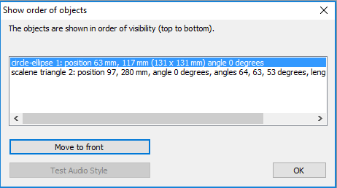
The Draw Mammoth Braille Tool (DRAWING TOOLS>Draw Mammoth Braille) allows you to insert Mammoth braille into your document. When you have selected a location for the Mammoth braille, a dialog window will appear, allowing you to enter the text you wish to insert.

The Draw Letters and Digits Tool (DRAWING TOOLS>Draw Letters and Digits) allows you to insert raised letter and number graphics into your document. When you have selected a location for your raised text, a dialog window will appear, allowing you to enter the text you wish to insert.
The Add Voice Memo Tool (DRAWING TOOLS>Add Voice Memo) is the last option on the standard toolbar. Selecting this option allows you to define an area to which your voice recording will be attached. When you have finished defining the area, choose the Record Microphone icon and record your voice memo. When you are finished recording, choose the Stop Recording icon.

For more information about the TactileView program, visit www.dreamvisiongroup.org

