Basic editing: Adding text labels
You may add text format labels to a file at any time. There are several formats of labels available for use in TactileView. The most commonly used type of label in TactileView is referred to simply as a “text label.” Text labels may be entered in plain text and be automatically translated to braille when they appear in the document, or they may be entered directly in braille through six-key input.
In addition to text labels, TactileView offers the option to add mammoth braille labels or print character labels that will be embossed as raised text.
NOTE: Labels may only be edited according to the input method used to create them. For example, a text label entered via braille (six-key) input may only be edited using six-key, and a raised print character label may only be edited as a raised print character label. Labels can’t be converted from one type of label to another.
Adding text labels
The most commonly used type of label in TactileView is referred to simply as a “text label.” Text labels may be entered in plain text, and then they are automatically translated to braille when they appear in the document. If you do not already have a file open, create or open one in TactileView to work in.
To add a text label, click the Add Text Label icon and then the computer keyboard entry icon . Next, click the location in the design area where you’d like to place your text label and begin typing.
In order to adjust the text label table settings, you must select (DRAWING TOOLS>Add Text Label: computer keyboard input.) A dialog will appear, allowing you to enter the text for your label and to select the braille table to use for translation.
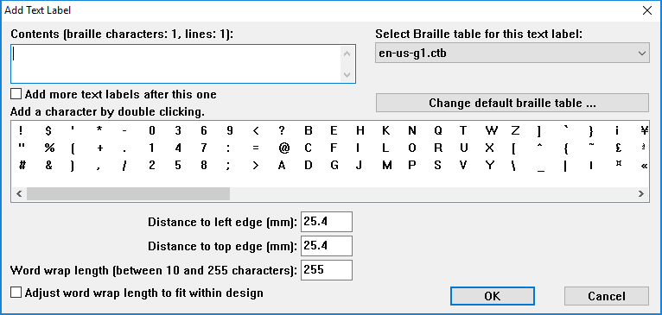
Enter the text you want to use in your label into the Contents box. Select the braille table to use for translation from the Select Braille Table for this Label combo box. [Note: For US English braille, select a table starting with “en-us.” En-us-g1 is the standard US English braille table for producing Grade 1 braille, and en-us-g2 is the standard one for US English Grade 2. Please refer to the Adding and Editing Braille Tables tutorial for information on how to edit existing braille tables or add your own.]
If you’d like, you can adjust the location for the text label by editing in the distance fields. You can also control the width of the text label by specifying the maximum number of characters you’d like it to have before the text wraps to the next line. Choose OK to close the dialog and insert the label.
The text label will appear in your file with the braille shown in black with the original text you entered in green on top of it, and there will be a green dot on the left edge of the label to indicate a text label entered with the computer keyboard (rather than braille keyboard entry).
Once you’ve inserted a label, you can make additional labels either by following this process again, or you can copy and paste your first label and then edit the text in the copy.
Adding text labels through six-key entry
Click the Add Text Label icon and then choose the braille keyboard entry icon . Click the location in which you would like to insert your label and begin typing. To adjust the braille-keyboard entry settings, you must click (DRAWING TOOLS>Add Text Label: braille keyboard input) and a dialog will appear.
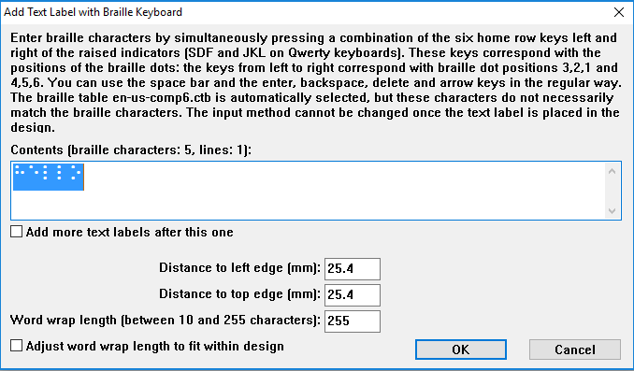
Enter the braille you would like in your label one character at a time in the text field on the dialog box. To enter a character, press all letter keys for the dots you want in your character at the same time, then release them at the same time. The letters f, d and s correspond to dots 1, 2 and 3, respectively, in the cell and the letters j, k and l correspond to dots 4, 5 and 6, respectively. For example, the letter n contains dots 1345. To enter this character, press f, s, j and k all at the same time, then release them.
The add braille label dialog also allows you to specify the location in which you’d like to insert the label (if different than where you originally clicked in the file) by filling in the distance fields, and you can size the text label by specifying the maximum number of characters you’d like it to have before the text wraps to the next line. Choose OK to close the dialog and insert the label.
The text label will appear in your file with the braille you entered shown in black. Letters that correspond to the braille character in the US English braille table are shown in green on top of the braille, but the braille itself should be checked for accuracy, not the green text. The green text will not be embossed. There will be a yellow dot on the left edge of the label to indicate a text label entered with the braille keyboard (rather than computer keyboard entry).
If you input a text label using the braille keyboard (six-key) input method, it may only be edited using six-key. The Add Text Label function will stay in braille keyboard entry mode until you click the Add Text Label icon , and then either click the computer keyboard entry icon or right-click in the design area and select Text and position: computer keyboard entry to change it back. The Add Text Label function will also be automatically reset to use computer keyboard entry if you close and reopen the software.
Adding mammoth braille labels
To add mammoth braille labels, click the Draw Mammoth Braille icon in the tool bar on the left side of the screen, then click the location in the design area where you would like to place the label. In the dialog that appears, enter the text you wish to appear in mammoth braille and adjust the position in which it should be inserted if desired. Choose OK to close the dialog and insert the mammoth braille label into your file.
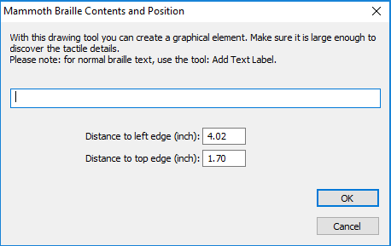
The mammoth braille label will appear in your file with the mammoth braille dots shown in bright blue. The original text you entered will appear behind the mammoth braille in light blue.
Adding raised print character labels
To add print characters that will be embossed in the shape of print letters, choose the Draw Letters and Digits icon from the tool bar on the left side of the screen, then click the location in which you’d like the raised print character label to be inserted. This launches a dialog that allows you to enter the text you wish to appear as print characters and adjust its location in the design area if necessary. Set the options as desired and choose OK to close the dialog and insert the label into your file.
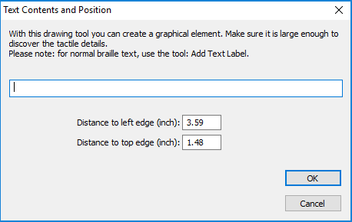
The raised print character label will appear in your file with the text you entered shown in bright blue.

For more information about the TactileView program, visit www.dreamvisiongroup.org

