TactileView Tutorial 3 – Basic Editing

Let’s begin by opening the TactileView Graphic Design software. This will automatically create a new, blank file in which you can create a new drawing from scratch.

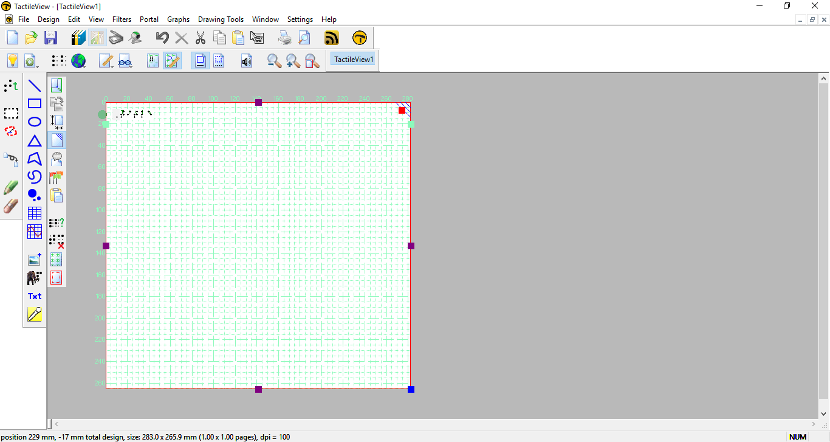

If you would like to work on an existing file, choose FILE>Open in TactileView and browse to the file you wish to work on.
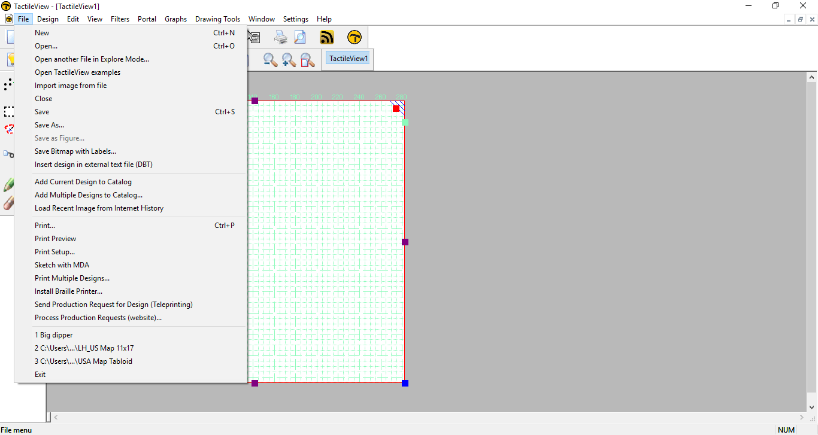

Or you may choose a file from the Online Design Portal (please see the tutorial "Scanning, Importing and Using the Portal" for more information).
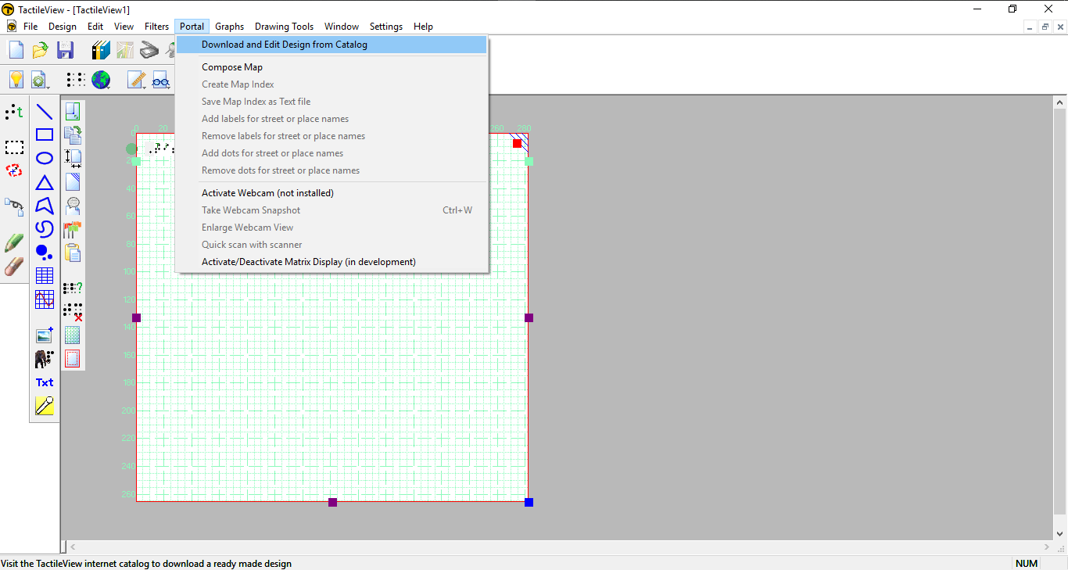

Now that you have a graphic open, review it to see where you would like to make changes. You can review it in the standard editing view, or choose FILE>Print Preview to see how the file will print.

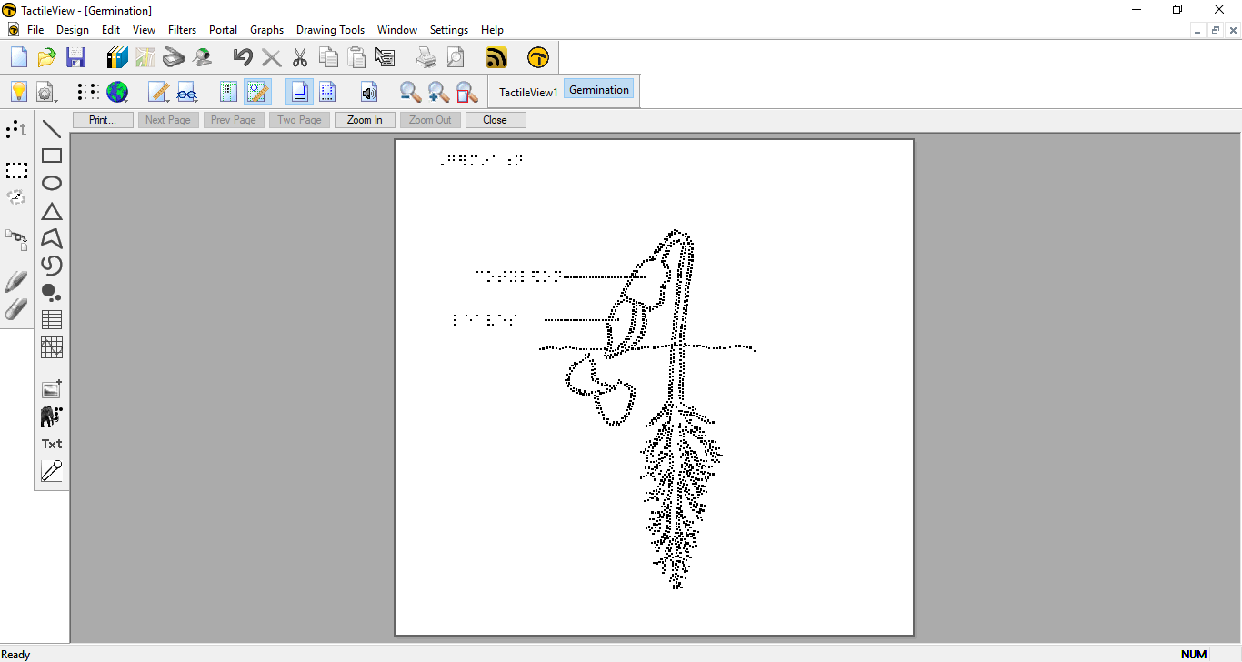

If you are viewing your document in print preview, choose the Close button on the print preview screen to return to edit view.
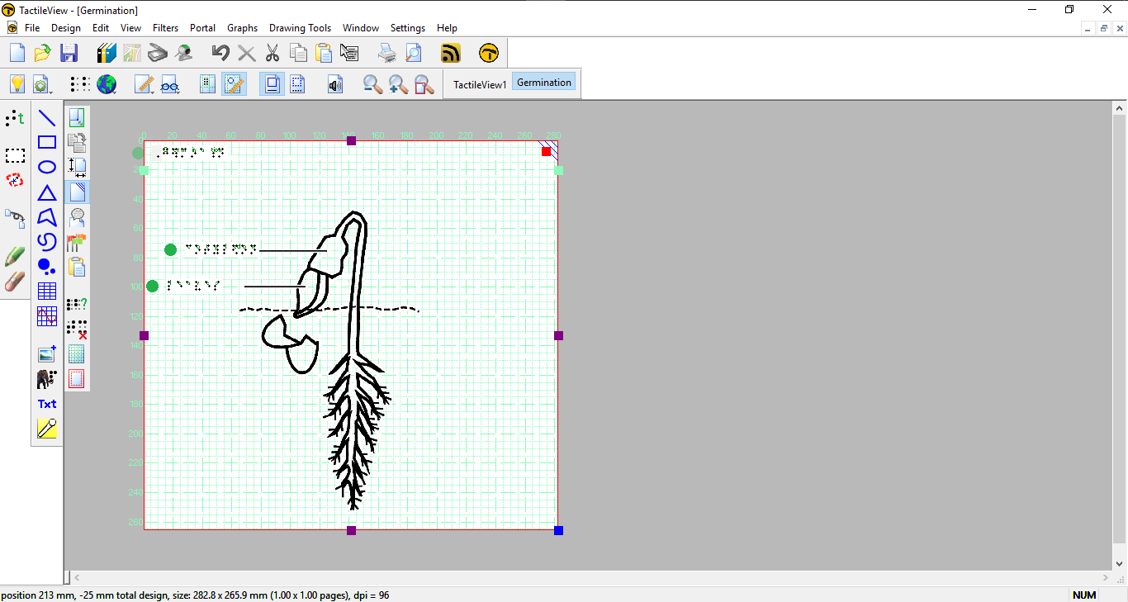

If you would like to add braille labels to your diagram, choose the Add Text Label icon from the drawing tool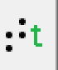 or select DRAWING TOOLS>Add Text Label. If you have not selected a braille table prior to adding a text label, you will be prompted to select a braille table of the language you prefer. Once you have selected the desired table, click OK.

Your braille and text label will now appear in the document and you can begin typing your label.

Continue adding labels and making other adjustments until your graphic is complete. To check how your document will print at any time, select FILE>Print Preview. When you have completed your graphic, it's time to print it.
Now you will need to adjust the paper size so that the graphic prints correctly. Please note that you must make sure your embosser has the same settings for printing as you are setting in TactileView. For an Index printer, you may change the paper size on the embosser through the MENU option on the control panel.

Next, go to the FILE menu and select Print Setup. Make sure that the paper size you would like to emboss on is selected. If appropriate for your graphic, you can change the page orientation to Landscape.

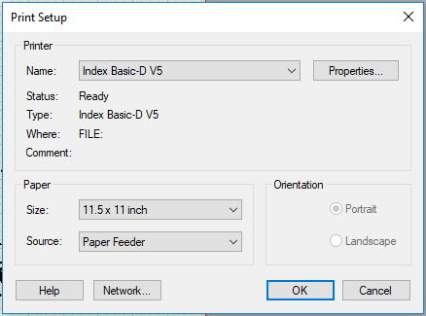

In TactileView, the red lines surrounding the graphic represent the paper size. Drag the square points to adjust the size of the graphic to fit within the paper margin lines.

Additional page format parameters are available through DESIGN>Design Format. Here you can adjust the page margins, centering, the graphic on the page and other options. Make any desired changes and choose OK.
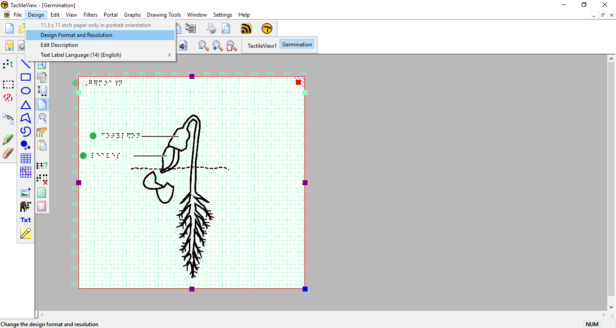
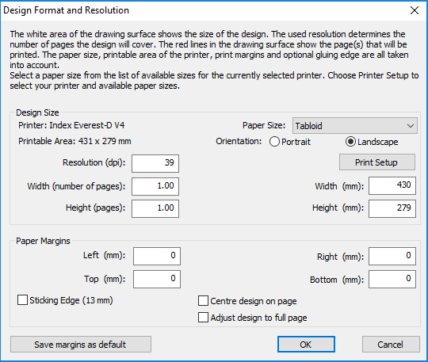

When you have finished selecting your print settings, print your graphic by choosing Print from the FILE menu. Verify that the printer you have chosen is a TactileView printer, then select OK to print. (Please review the tutorial "Getting Started" if you have not yet installed a braille printer.)

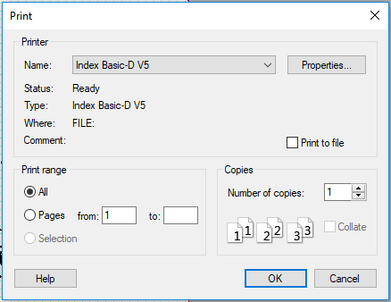

For more information about the TactileView program, visit www.dreamvisiongroup.org

